Local Ordained Ministry Application Form
Please fill this Form in, preferably on a computer and save as a named file. If you need to fill in by hand, please print off and add in spaces between the questions. Email (or deliver) documents to the Candidate Convenor in your Presbytery.
With this Form you also need to submit:
a) a 'statement of call' explaining your sense of call to ministry
b) your CV, with your work history, qualifications and other training
c) your academic record
d) a covering letter with anything else you think is relevant to your application

CONTACT DETAILS

Full name:
Preferred name:
Date of birth: Male/female

Home address:

Alternative address:

Contact Numbers: (home) (work)

Email:

FAMILY

Marital status: Spouse’s name:

Children living at home, names and ages:

Other financial dependents:

Previous marriages/civil unions:

CHURCH INVOLVEMENT

Where and when did you become a communicant member of the church?
(Applicants must have been members for a minimum of two years at the time of their application to the presbytery.)

(If different from the above) Where and when did you become an active member of the
Presbyterian Church of Aotearoa New Zealand or Co-operating church?

What do you consider to be your home church?

How are you involved in your congregation at the present time?

FAITH

How would you describe your relationship with God?

What are your central convictions about God?

SKILLS AND ABILITIES

What experience do you have of “reflection-based supervision”? (someone helping you to reflect on your practice and experience in a work situation)

What do you and others consider to be your skills and abilities relevant to pastoral leadership?

What weaknesses are you aware of?

What areas of strength would it be helpful to develop?

What leadership experience have you had?

LOM training involves academic study. How is this for you?

Which languages do you speak? What is your principal language? What are your skills in written and/or spoken English?

COMMUNITY INVOLVEMENT

What community activities have you been involved in?

LEISURE

What hobbies, sports or other interests do you have?

CROSS-CULTURAL EXPERIENCE

What experience have you had of cultures other than your own?

PERSONAL CIRCUMSTANCES

What is your availability for ministry and further training?

What other commitments do you have?

REFEREES

Please supply the names and contact details of at least TWO referees:

Name: Relationship with you:
Address:
Email:
Phone: (wk) (hm) (cell)

Name: Relationship with you:
Address:
Email:
Phone: (wk) (hm) (cell)
DECLARATION

I understand that my presbytery, in fulfilling its obligations, may consult the nominated referees, or any other person, and I hereby grant them permission to do so.

If I am accepted and called, I undertake to complete any training requirements as agreed in discussion with the Knox Centre for Ministry and Leadership and the presbytery.

I have / have not (delete one) previously applied to be considered for training for ministry with the Presbyterian Church of Aotearoa New Zealand or other denomination.
If you have, please provide further information in your covering letter.

I have / have not (delete one) been convicted in a court, either in New Zealand or elsewhere, of an offence carrying a maximum penalty of a fine of $1,000 or more, or where the offence carries a penalty of imprisonment for whatever period. If you have, please give further information in your covering letter.

I give permission for a Police check.

I am aware that the presbytery will require my assent to the doctrinal standards of the PCANZ as set out in the Book of Order and decisions of the General Assembly.

I declare that to the best of my knowledge the statements made in this application are true in every respect.

Signature Date

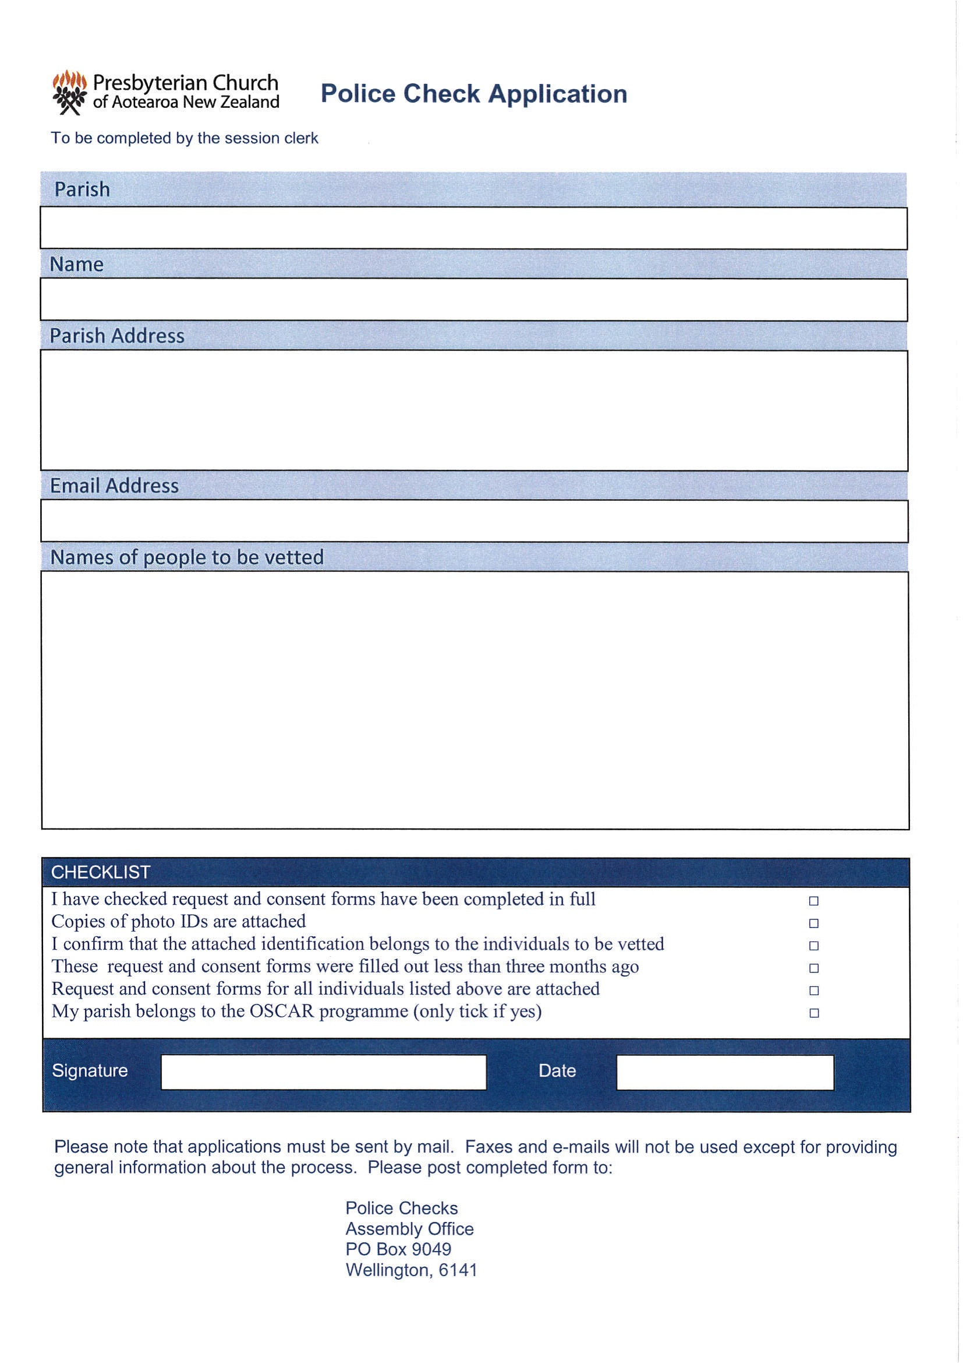 Note: Candidate Convenor to fill in. Instead of 'Parish Name' write your presbytery name,
and add "LOM Application" beside the applicant's name.

