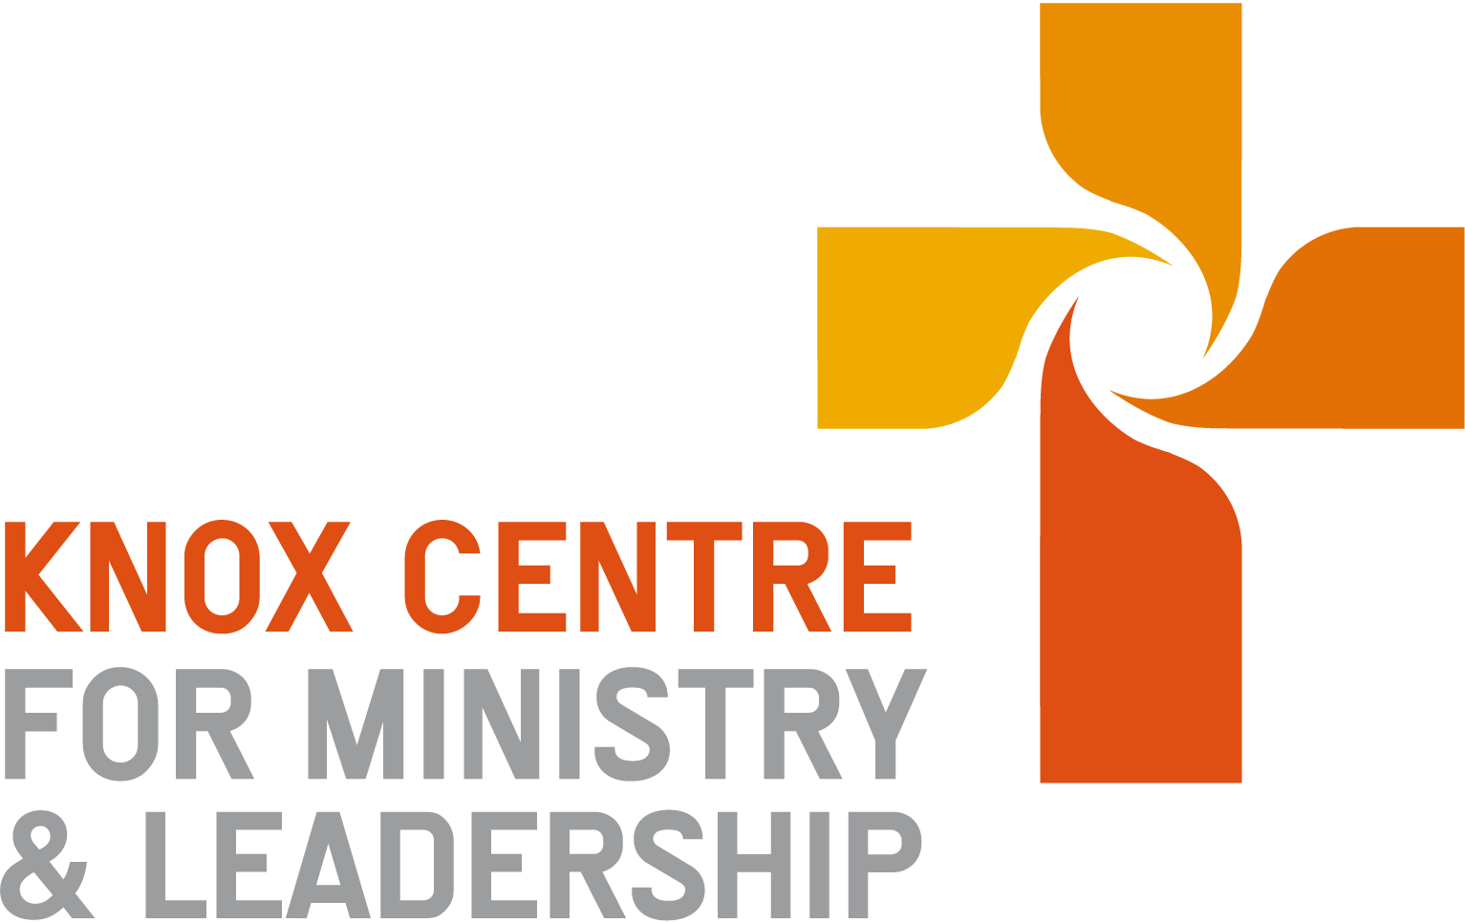
Mission in Community Course 2022-2023
Course Coordinator

Content
A repeated theme heard in the PCANZ is the need to develop leaders in mission. In a post-Christian climate in New Zealand, mission, and theologically speaking, God's Mission, is the primary focal lens helping churches and ministries interpret their identity and purpose. In one sense then, ‘mission’ colours and shapes all courses and leadership formation of KCML.

However, this course singles out the conduct of mission to focus specifically on intentional practices, frameworks and skills in leading groups and nurturing churches in mission.
Mission is a broad concept and means many things for people. The PCANZ lists five lenses by which we understand the church lives out the mission and ministries of Christ in the world.
“The Presbyterian Church of Aotearoa New Zealand believes it is called by God to work with others in making Jesus Christ known through –

- Loving service responding to human need – to proclaim release to the captives, recovery of sight (Luke 4:18b)
- Proclaiming the gospel – annointed to bring good news to the poor (Luke 4:18)
- Seeking to transform society – let the oppressed go free; year of Lord’s favour (Luke 4:18; 19)
- Teaching and nurturing people in Christian faith - annointed to bring good news to the poor (Luke 4:18)
- Caring for God’s creation year of Lord’s favour (Luke 4:19 echoing Deut 22:6)

This course has chosen to focus leading mission around a different but overlapping set of intentional practices, with the emphasis on implementing for different contexts.

1. Listen in Place: Prayerful attentiveness and discernment in context (essential for all)
2. Serve: Mercy and incarnational love (loving service; creation care)
3. Evangelise: Gospel sharing and the evangelising community (proclaiming)
4. Act Justly: In ethics & prophetic action (transforming society; creation care)
5. Faithful dialogue: Engaging with cultural ideas, religions, underlying social narratives (loving service, transforming society, teaching, creation care)
6. Initiate: Educating for knowing Jesus and entering faith community (teaching and nurturing)
7. Plant & Form New Seedlings: Embodying the Gospel in new social expressions (loving service, proclaiming, transforming society, teaching and nurturing, creation care)

Ministry is the practice of mission in the context of what God has done in Christ through the Gospel. The big story to mission is that God in Christ brings about the new creation in the midst of the old through Christ’s life, death, resurrection and ascension. These intentional practices therefore cannot be limited to human or ‘church’ agency alone and therefore comprise ministries of Christ. They are led by the living resurrected Christ and empowered by the Holy Spirit. So not only is the church making Christ known through these ministries, but the church joins with and participates spiritually in Christ by these ministries. Christ is encountered anew by the church as it joins in God’s mission.
These intentional practices may be framed and related to the functions and ministry of local faith communities in terms of the following overlapping and interacting spheres of ministry; worship, mission, communal life and spiritual/Christian growth

Mission, intentional practices
Serve, Act Justly, Faithful dialogue, Evangelise, Initiate
Communal Life
Plant and form new seedlings

Spiritual
/Christian Growth
Worship
Faithful presence with/in God

Listen in Place
Worship: Through Christ, bringing praise and prayer to God, hearing and receiving from God, being sent to enjoy and proclaim God, through gathered acts of contextually rooted transforming worship.
Embodied Mission: Participating in God's love for the world (John 3:16, John 20:21), the reconciling and renewal of all things (Eph 1:10…Rev 21:5) through the Gospel of Christ.
Spiritual and Christian Growth: Attending to God, learning about God's activity and character, and participating in God's life. We are formed as we engage the Bible, study church history and traditions, reflect theologically, welcome God's grace and forgiveness, describe our lives and longings in prayer, and act in congruence with God's grace.
Communal Life: Attending to one another, and discovering God's grace in Christ through those around us. For instance, in how we treat one another, manage time, money justice, care and mercy with each other. How we organize the relational life of the whole community and extend that outward.

Course Format
- Frameworks for the practices will be explored within block course modules of 3 hours.
- Missional leadership skills will be taught "in context" through 4-5 x 2 hour online tutorials each year.
- Implementation Assignments, which are designed to encourage you to learn by doing. There are two of these, one in each year and these comprise substantial pieces of practical work in your placements.
- Some theoretical background reading, interpreting and reflection. This will dovetail with the block course modules and also an assignment drafting out a study course for church use.

Outcomes
Leaders who enable mission practice and mobilise the "go" in God’s mission
- To attend to God’s mission agency in Christ, reflect missiologically and draw others into this process
- To grow in prioritising and nurturing a church/ministry setting in contextual, faithful and self-giving witness to Jesus Christ in the world.
- To develop skills of mobilising discernment, innovation and action in diverse and boundary crossing settings

Block Course Modules
Intro to Mission in Community Practices & 1. Listening in Place | Summer 2022 Intern introduction
Serve (Mercy and incarnational love) | Summer 2022 (Year B1)
Act Justly (in ethics and prophetic action) & Faithful Dialogue | Winter 2022 (Year B2)
Planting New Seedlings (embodying Gospel in new social expressions) | Spring 2022 (Year B3)
Evangelise A (Personal dynamics of Gospel sharing) | Summer 2023 (Year A1)
Evangelise B (The evangelising community) | Winter 2023 (Year A2)
Initiate (to following Jesus & entering the faith community) | Spring 2023 (Year A3)

Missional leadership skills and practices: online tutorials
Year One 2022: Listening in the Neighbourhood

By 30 June 2022; confirming assignment with Mentoring Minister and church council. Design plan of recruitment, and plan of taster and subsequent meetings.
- Thursday 4th Aug, 3.00-5.00 pm Mission as gift, calling and promise.

- Thursday 25th Aug, 3.00-5.00 pm Cultivating congregational spaces for listening, conversation and shared practices of missional attentiveness.
Reading the Neighbourhood taster & meeting 1 underway.
- Thursday 15th Sept, 3.00-5.00 pm Being present and listening in neighbourhood/context.
Reading the Neighbourhood meeting 2 & 3 underway
- Thursday 13th October, 3.00-5.00 pm Neighbourhood Canvas: Reading the Neighbourhood is part of a wider discernment process.
Reading the Neighbourhood Review meeting 4 and presentation to church council underway
Submit assignment reflection 4th Nov 2022.
Year Two 2023: Mission Action Experiment (MAE)

Dates will be confirmed in 2023 – you should plan to begin late March/early April with taster session and confirming your team.

- Thursday 13th April, 3.00-5.00 pm Deepening the Listening Canvas: Diagnosing social and spiritual stories.
Mission Action Exp Meeting 1
- Thursday 25th May, 3.00-5.00 pm Recognising possibilities of God. Discernment Canvas. Part A
Mission Action Exp Meeting 2
- Thursday 22nd June, 3.00-5.00 pm Discerning a Christ patterned opportunity for mission innovation experiment. Discernment Canvas Part B.
Mission Action Exp Meeting 3
- Thursday 27th July, 3.00-5.00 pm Designing and planning experiment in Christ patterned mission innovation.
Mission Action Exp Meeting 4
Implement Experiment
- Thursday 21st Sept, 3.00-5.00 pm Reviewing experiments and reporting back.
Mission Action Exp Meeting 5 and presentation to church council

Assessments

Assignment 1 – Listening in the Neighbourhood
In Year 1, interns will engage a group of people in their placement in an exercise of missional attentiveness. This involves a listening/seeing exercise of ‘reading’ the local neighbourhoods/community, listening to God and one another and cultivating discernment. This will test skills of group leadership and initiating an action-learning exercise in a congregation. The four online tutorials will provide group-based coaching and support with skills and practices for this assignment.

Write-up: 1500 words. Due 4th November, 2022.

Assignment 2 – Design a Study Course Outline
By May of second year interns will have designed their own learning tool for use in a local congregation/ministry context. This will introduce the character and theology of God’s mission to a congregation in workshop or small group mode and express the PCANZ five faces of mission in such a way that is rooted in a New Zealand context, and relevant to a likely future constituency. The outline of the learning tool may be supplemented by extra appendices/ reading, audio-visual, online materials – not included in the word count.
You will be expected to display familiarity with key theological themes and practices in local mission and contextualisation, as you interpret and design this for your target group.
2000 words. Due 12th May, 2023.

Assignment 3 – Mission Action Experimenting
In Year 2, interns will develop upon the learning, relationships and experience they have gained from Assignment 1. They will initiate and lead a new group in their placement to discern, design and implement a small one-off mission action experiment. It follows the process of reading the neighbourhood and deepens this into a focal experiment in mission action that explores possibilities for Christ patterned ministry innovation and gives people experience in how to participate with God in local mission. Five online tutorials will provide group-based coaching and support with skills and practices for this assignment.

Writeup: 1500 words. Due 6th Oct, 2023.
Plagiarism statement
It is the responsibility of the intern to make sure that all work submitted to KCML is their own. Plagiarism is defined generally as:
- copying or paraphrasing another person’s work and presenting it as your own;
- being party to someone else’s plagiarism by letting them copy your work or helping them to copy the work of someone else without acknowledgement;
- using your own work in another situation, such as for the assessment of a different paper or program, without indicating the source.
Plagiarism can be unintentional or intentional. Even if it is unintentional, it is still considered to be plagiarism. Where it is found that plagiarism has taken place, penalties will be applied (see the 2022 Internship Programme Handbook).

Bibliography
At times, extra readings will be offered before, during or following block course (on moodle) or for participating in online tutorial. Requirements of what needs to be read before a block course or an online tutorial will be specified in advance.
While reading is not being “assessed,” it provides an important means of deepening and continuing course engagement with mission frameworks and practices.
Texts worth consulting or referencing
Bevans, S. B. & Schroeder, R. P. Constants in Context: A Theology of Mission for Today. Maryknoll, NY: Orbis Books, 2004.

Dewerse, R. Nga Kai-Rui i Te Rongopai: Seven Early Maori Christians. Rotorua: Te Hui Amorangi ki te Manawa o Te Wheke, 2013.

Goheen, Michael W. A Light to the Nations: The Missional Church and the Biblical Story. Grand Rapids: Baker Academic, 2011.

Holt, Simon Carey. God Next Door: Spirituality & Mission in the Neighbourhood. Brunswick East: Acorn Press, 2007.

Morisy, Ann. Journeying Out: A New Approach to Christian Mission. London: Morehouse, 2004.

Newbegin, Lesslie. The Open Secret: An Introduction to the Theology of Mission. Rev Ed. Cambridge: Eerdmans, 1995.

Pickering, Sue. Listening and Spiritual Conversation. London: Canterbury Press, 2017.

Ramachandra, Vinoth. Faiths in Conflict: Christian Integrity in a MultiCultural World. Leicester: IVP, 1999.

Roxburgh, Alan. Joining God, Remaking Church, Changing the World. New York. Moorehouse, 2015.

Ruka, Jay. Huia Come Home. Auckland: The Parenting Place, 2017.

Skreslet, Stanley H. Picturing Christian Witness: New Testament Images of Disciples in Mission. Grand Rapids: Eerdmans, 2006.

Sparks, Paul. & Soerens, Tim. & Friesen, Dwight J. The New Parish: How Neighbourhood Churches are Transforming Mission, Discipleship and Community. Downers Grove: IVP, 2014.

Walls, Andrew. & Ross, Cathy. (eds) Mission in the 21st Century: Exploring the Five Marks of Global Mission. London: Darton, Longman and Todd, 2008.

Ward, Kevin R. Losing our Religion? Changing Patterns of Believing and Belonging in Secular Western Societies. Eugene: Wipf & Stock, 2013.

Wells, Samuel. Incarnational Mission: Being with the World. London: Canterbury Press, 2018.

Zscheile, Dwight J. The Agile Church: Spirit Led Innovation in an Uncertain Age. New York: Moorehouse, 2014.

