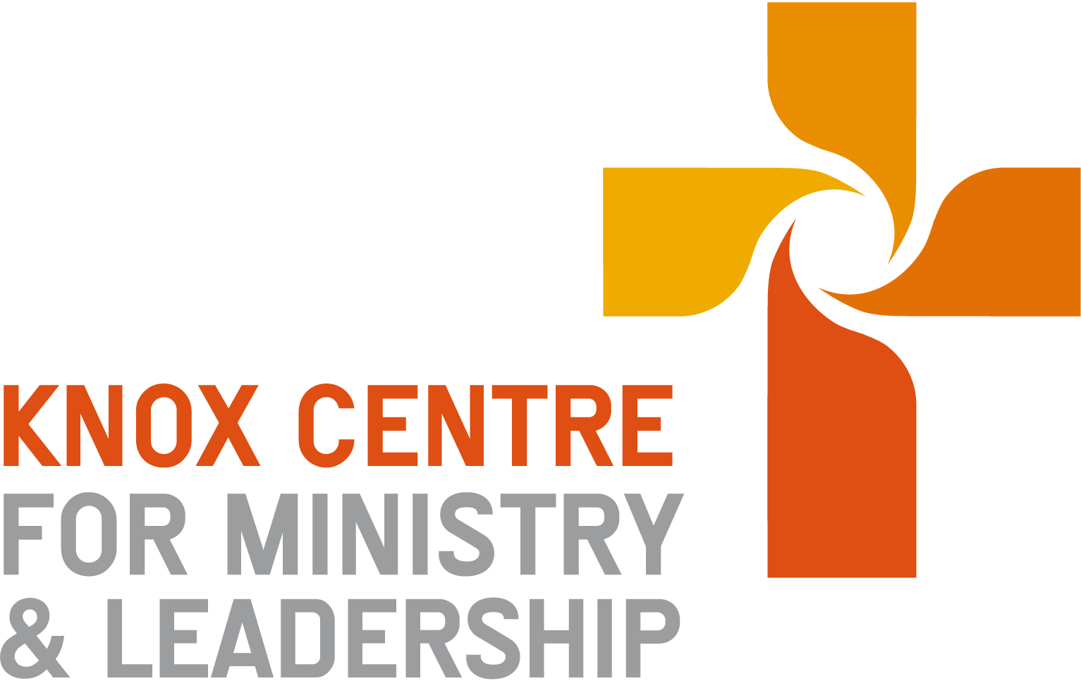
Transforming Worship 2022-2023

Course Coordinator:

Content
This course seeks to build a familiarity with the richness of the worshipping heritage within the Reformed Tradition, and to understand present trends and realities in the light of what has gone before. It also seeks to build creative agility in adapting this tradition for the present realities of congregational life within the PCANZ. Worship is the transformative meeting place between God and people, yet is so often a flashpoint for disagreement and disunity within congregations. This course will seek to develop the ability to lead worship that has depth and breadth enough for God’s people to worship together.

Course Format
- Frameworks, skills and materials in key topics will be explored within block course modules of 3-6 hours each and supplemented by background reading.
- Worship design & leading skills will be practiced in situ in placement and in some of the worship occasions at block course.
- Assignments including exegeting worship services, sacramental or sung theology and worship leading skills.
- Your Kete. Resource Gathering

Outcomes
Ministers who design, engage and lead people in contextual, authentic, transformative and faithful worship to God.

- To comprehend why we do what we are doing in worship, by attending to Scripture, theology, church history, context and culture.
- To deploy this awareness in the creative and theological task of shaping, enabling and leading Christian worship in a variety of contexts.
- To equip interns in the practical dimensions of planning and conducting services of Christian worship for a variety of occasions.
- To incorporate and adapt course learning to the leading of worship in placement settings and reflect on challenges of context, unity, faithfulness and creativity.
- To expose interns to and develop their own worship resources

Block Course Modules
Intro to Worship. Getting to grips with Presbyterian and Reformed Tradition and Practices. | Summer 2022 Intern introduction
Year B1 Summer: Music & Sung Theology | Summer 2022
Year B2 Winter:  - Funerals  - Leading Change in Worship | Winter 2022
Year B3 Spring: Public Worship Leading, Language & Voice | Spring 2022
Year A1 Summer:  - Public Prayer - Crafting Liturgical Prayer & Modes of Corporate Prayer  - Occasional Services | Summer 2023
Year A2 Winter: Communion | Winter 2023
Year A3 Spring: Baptism | Spring 2023

Worship design & leading skills – in practice
- The usual practice is to be involved in design and leading worship components or order of service a minimum of 2 times a month.
- In addition you will be asked to contribute to block course worship components. Details of these are given below.
- You will co-design and co-lead at least one worship service at block course in both Year 1 and 2. At the discretion of the Course-Coordinator, in conjunction with other faculty, you may be asked to co-lead more than one worship service per year, attending to particular skills.
- You will undertake a "Crit" service by designing, leading and preaching for your sending Presbytery in Sept-Oct of your final year.

It is the nature of the internship that your practice will be evaluated in terms of immediate feedback as required. This will come from your Mentoring Minister, more occasionally from Ministry Review Group and from your Tutors/ Fieldwork Coordinator. For the Crit service, the Presbytery will appoint a reviewer.
In Ministry Placements
It is not uncommon as interns progress through this course to feel occasional tensions between liturgical issues raised in reading and class-work and what they observe and experience in their ministry placement. Such tensions, constructively handled, can be the occasion for learning. Take time to converse with your mentoring minister, but always in a respectful manner, and use open-ended questions that enquire rather than statements that judge or criticize.

Assessments
Assessments will use the Ready for Ministry (RFM) Criteria.

Assignment 1 – Exegeting Worship Services and Traditions
Find a recording online of a traditional Presbyterian service of worship that follows the liturgical structure outlined in the introductory lecture (Call, Adoration, Confession etc). Along with this, watch or visit two other worship services from different styles, denominations and tradition (either online or arrange to fit in with your placement timetable in the first few months of the year)
Consider the pattern of a classical worship service that you read in the prologue of The Worship Sourcebook and also the cultural and historical setting of worship that you read about in Chapters 1- 3 of A Primer on Christian Worship.
- Review each service in light of this. Reflect on what you observed and experienced.
- Note similarities and differences with the classical pattern.
- What do the style, structure and leadership of each service suggest to you about the underlying (a) cultural and historical origins (b) theologies of worship in these places?
- Reference your discussion (footnote) to relevant material in the nominated texts.

Due: 20 May 2021. 1500 Words

Assignment 2 – Liturgy Creation
Throughout your second year you will be required to submit a prayer or piece of liturgy each month for comment and critique from February to November.
There will be 10 submissions, due on the first of each month.
With regard to the February and March submissions, given the pressures of summer holidays and Summer Block Course, it is fine to submit something that you have used from the Advent or Christmas period. However, the usual expectation will be that you submit something from the month preceding each due date.
You are required to submit each of the following, in any order that you choose:
- A Call to Worship, Dedication of the Offering and Blessing/Sending (x2)
- A Prayer of Adoration and Confession, and Assurance of Pardon (x2)
- A Communion Liturgy (x2)
- A Prayer of Intercession (x2)
- Two other pieces of your choice, perhaps a pastoral prayer from a funeral, or a reflective response following a sermon, or one of the prayers listed above that you want to try with a different creative approach.
Each submission ought to have discernible links between either the Scripture being used in the service, the Church season, or both.
In your submissions you are required to engage with the following foci at least twice across the year.
- Using inclusive and expansive language for God (see Maggi Dawn’s article for guidance – see Moodle).
- All age
- Tactile prayer/liturgical action – or a prayer that uses movement.
- Responsive – spoken as well as another form of response. Consider Pierson’s difference between ‘participation’ and ‘engagement’ (see Moodle).
Each submission will be accompanied by a brief commentary (~200 words) outlining which Scripture or season is being addressed, which foci is being engaged with, any challenges that occurred in its execution, and anything that you would do differently next time.
Due: On the 1st of each month, February to November.
Where the Winter and Spring Block Courses fall on the 1st of the month – the due date will be the day before block course commences.
2000 words (200 words per assignment) of commentary alongside the prayers/liturgies themselves.
Assignment 3 – Compiling Your Kete
This assignment requires you to resource gather all the way through your internship. As you design and write worship services, experience other services, receive resources at block course, and research, utilising online access and the Presbyterian Research Centre, you collect a range of resources that can be utilised and adapted in the future.
Due: 3rd Nov 2023. Unlimited (see minimum requirement below)
You may put material in this Kete of your own choosing however there are some required items which you will demonstrate you have researched, collected or designed yourself.
Please include
- A funeral liturgy for a child/ baby.
- A full service order (words of prayers etc) at Easter time that you have been involved in designing and leading.
- A Karakia and liturgy that you could lead and pray at the opening/blessing of a new community facility. (In Maori)
- A short communion liturgy (for use in small and constrained time and place settings) that can be led from introduction to final prayer in 7 minutes, and covers all the key classical movements of the Eucharist.
- A prayer about creation care and/or climate justice
- Words of prayer and scripture you would use at the bedside of a person close to death.
- A prayer of confession that invites participants to engage other senses as well as using or listening to words
- A blessing to be given by children under the age of 10 at a large worship service
- A prayer of intercession/prayer for others in the season of Advent that is interspersed with a singable refrain or chorus.
- An order of service from the Iona tradition
- The Lord’s Prayer in Māori, a Pacific Language and an Asian language
- A prayer of lament in Lenten season using symbols and actions to strengthen it
- A liturgy of prayer and remembrance for women who have had miscarriages or experience infertility
- A prayer that responds to and incorporates a Psalm.
- A visual liturgy (no spoken words) you would use for a time of thanksgiving in the service
- Reprint of the TAP Māori Worship Resources for PCANZ.
- Six songs from outside your favoured genre (hymns, chorus’s, songs, Taize chants etc)
- An all age service order centred around a biblical theme/text.
- The service order for ordaining and inducting elders, with scribbled comments on where you would offer local variations, adaptations
- Outlines of words/structure/ prayers etc you would use for a child dedication, a child baptism and an Adult baptism

Assessment will comprise submitting your Kete for review in terms of readiness for ministry criteria.
Please Note
- If you collected a resource in electronic format –you will only be expected to print a sample page or two. However – include the whole resource on a memory stick that is included in the Kete when submitted.
- Collecting non-text based materials and multi-media is acceptable as well (and see in list above) You are not required to physically supply the whole set of materials in the submitted Kete, however – include a note of the materials on a pages or page on which the process/liturgy is outlined.
- Note and attribute the full source if you have extracted a resource from a book or web-page.

Plagiarism statement
It is the responsibility of the intern to make sure that all work submitted to KCML is their own. Plagiarism is defined generally as:
- copying or paraphrasing another person’s work and presenting it as your own;
- being party to someone else’s plagiarism by letting them copy your work or helping them to copy the work of someone else without acknowledgement;
- using your own work in another situation, such as for the assessment of a different paper or program, without indicating the source.
Plagiarism can be unintentional or intentional. Even if it is unintentional, it is still considered to be plagiarism. Where it is found that plagiarism has taken place, penalties will be applied (see the 2022 Internship Programme Handbook).

Required Texts
The Worship Sourcebook, 2nd Ed 2013 (Includes CD Rom), published by the Calvin Institute of Christian Worship, is a Reformed but non-denominational book, of broad evangelical flavour, with a theoretical introduction to Christian worship followed by a wealth of liturgical and prayer resources for regular Sunday worship, including communion and baptism. NZ $49 on Book depository
A Primer on Christian Worship. William Dyrness (Eerdmans 2009), covers the historical, theological and contemporary cultural backdrop to worship. NZ $36.50 on Book depository or cheaper as an ebook.

Recommended Service Books

The Uniting Church of Australia Uniting in Worship 2 (with CD) 2006, is a complete compilation of service liturgies and prayers suited for the Uniting and Presbyterian church context. It combines the best of contemporary language and classical forms, offers services for many different kinds of occasions including weddings, funerals and blessing ceremonies. Comes with a CD-ROM so materials can be cut and pasted into orders of service. Available through Koorong.
The Anglican Church’s New Zealand Prayer Book, 2002, reflects our New Zealand context. Many of the prayers and responses are offered in Maori as well as in English. If you are going to weave Te Reo into your conduct of worship, this book contains what you need. http://anglicanprayerbook.nz is the official online version (free) and you can copy and paste from here.
The Church of Scotland’s Book of Common Order, 1994, offers a good basic selection of orders of worship and supplementary resources for communion, baptism, marriage and funeral services. It also offers ordinances for a range of occasional services such as the ordination of elders, the dedication of churches and the blessing of new homes. The compactness of this book makes it easy to use.
Recommended Web Based Liturgical Resources
Text this Week (www.textweek.com) An encyclopedic sorting house for lectionary-based resources and can also be searched via a scripture index. Includes commentary, children’s materials, prayers, art and movie links.
Jonny Baker Resources ( http://jonnybaker.blogs.com/jonnybaker/worship_tricks) Creative ideas that extend the conventional.
The Work of the People (http://www.theworkofthepeople.com) Visual resources, short reflections and liturgical materials, including lectionary based materials.
Lectionary Prayer Resources from Melbourne (http://www.laughingbird.net/LaughingBird/Welcome.html)
Contemporary Ideas, Images, Clips and Sources for Lectionary Readings (http://seedstuff.blogspot.co.nz)
Prayers for worship and linked to scripture readings (http://re-worship.blogspot.com.au) Sourced internationally.
Worship Reflections, Prayers and Activity Resources from Roddy Hamilton (Creative Church of Scotland Minister) that utilize fresh language, creative insights, contemporary and ancient forms. Go to Listening to the Stones (http://newkilpatrickblog.typepad.com) and search his archives and links including Mucky Paws, Chocolate Teapots, Spill the Beans
Lectionary and Worship Materials that link to Christian Education/Sunday School. Subscription based (http://www.seasonsonline.ca/412/worship_resources)
Creative all age worship ideas, linked to lectionary with contemporary twists (http://www.spillbeans.org.uk) purchasable with free online samples.
Multi-age worship resources (http://ctm.uca.edu.au/children-and-families/multi-age-lectionary-resources) providing links to Scripture Union, Living Stones and other resource sites.
Prayers, Call to Worship for the Lectionary Readings. United Church of Christ, USA (http://www.ucc.org/worship_worship-ways)
Contemporary Arts and Visual Sources for purchase from Christians in the Arts (CIVA) USA (http://civa.org)
Other Recommended General Texts
One Bread, One Body: Exploring Cultural Diversity in Worship. C Michael Hawn. (Plymouth: Alban Institue, 2003)
Worship in the Best of Both Worlds: An exploration of the Polarities of Truthful Worship. Phillip Greenslade. (Milton Keynes: Paternoster, 2009) Explores the tensions present in worship practice across many church settings, including; self-fulfilling and God-glorifying, charismatic freedom and liturgical order, transcendent otherness and transforming intimacy, praise and lament, tradition and innovation, jubilation and justice.
The Work of the People : What We Do in Worship and Why. Marlea Gilbert. (Alban Institute 2006.)
Desiring the Kingdom: Worship, Worldview and Cultural Formation. James K. Smith. (Grand Rapids, Baker Academic, 2009). Explores the formational potential of worship and its ability to shape our affections in the following of Christ.

Worship Components of Internship
Worship is woven throughout the internship as the focal way in which God engages with us collectively, and directs our learning and ministry environments. Through worship we practice being God’s people as we listen, pray, sing, see, proclaim and respond.
Block Course Worship
At block courses, there will be an Intern-led worship service at the end of the Block Course. Relevant feedback will be offered by the worship course coordinator to those leading, however this does not contribute directly to assessment. Fuller instructions are listed below.
Morning Devotion, Midday and Afternoon Prayer
At the beginning of a block course day, there will be a short devotional focus of 10-12 minutes led by one of the interns, just before lunch, a prayer for others and at the end of the day, an examen prayer exercise, led by an intern or tutor.
Guidelines for Worship Services at Block Courses
- You will be notified 6 weeks before the Block Course that you are leading worship and of the other interns you are working with.
- Seek to lead the gathering in receptivity to God’s presence and Word to us, and trust Christ to carry the worship through the agency of the Holy Spirit. Prepare prayerfully. While you may be nervous leading your peers and lecturers, remember we are not the audience in worship and this is not a performance.
- In general, follow a classical pattern of gathering – word – sacrament– sending that you are exploring in the worship course. Pay attention to where you are in the church calendar. Within this there is room for variety and creativity, visual and symbolic components, and expressing yours and the worshippers’ gifts and responses.
- You are encouraged to be creative and integrate liturgical approaches that are familiar alongside at least one that is new or challenging to them and/or the worshipping community.
- Regarding Scripture, you can work with either lectionary passage(s) or a passage the group discerns together. The chosen passage(s) will inform each element of the service.
- The Word (sermon or preaching) component should not be longer than 5 minutes. Interns are encouraged to use alternative ways to engage with scripture beyond delivering sermons, which are covered extensively in the Preaching course. Discuss with the Worship Course Coordinator if you want ideas.
- You may wish to use parts of liturgies from service books however you are encouraged to adapt these, draft your own prayers and weave together a coherent order of elements.
- Design a worship service that is no longer than 30 minutes. (including a reflection on Scripture, and, if possible, communion) Simplicity and an uncrowded design is more effective.
- You do not have to do it all. You are responsible (usually with other interns) for the order and overall leading of the worship, however there is opportunity to involve others in readings, music and other creative responses.
- Music and Song can be used, but do not have to be. Choose and liaise carefully with musicians or recorded pieces to connect with the musical ability of the current community. Consider the diversity of worship expressions and ethnicities present in the worshipping community rather than just working with your favourite music or songs.
- Think ahead to the choreography of your worship service and its relationship to the narrative and content of the service. What kind of conditions do you want to encourage at the beginning as people enter the space, silent reflective, relaxed interaction, focal point of art or props? Where will you stand for different elements? What spaces of silence or spontaneity do you plan to deploy if any? What transitions need to be negotiated, such as between word and sacrament and in how people share the peace or receive communion.
- It is encouraged that Intern-led worship services include communion. This is usually practiced through intincture (dipping bread in a common cup of wine). Depending on the space used for the worship and the design of service, the choreography of communion can vary, however be explicit and clear about the practice you are inviting people to use in this celebration. Consult with the KCML Registrar for the bread and wine and the vessels.
- Whether you require a printed order of service or a data projector, these need to be arranged ahead of time. Contact the Block Course Coordinator and/or the Registrar.
- You may nominate preference for a space, including one of the Chapel’s at Knox or Salmond Halls, or in other venues (if not in Dunedin) as appropriate. Please discuss this first with the Worship Course Coordinator.
- The Worship Service is positioned at the end of the Block Course, so you are able to make preliminary arrangements ahead of the course, and then collaborate on the finer details during the Block Course itself.
- It is OK to express your personality, culture and gifts in leading our worship. Everyone is different and part of the gift of this occasion is valuing the unity in diversity that is present through Christ.

This is not a formal piece of assessment, but you will receive feedback from the Course Co-ordinator following your service.

Guidelines for Morning Devotion, Midday and Afternoon Prayer
Morning Devotion
This is an occasion to lead the KCML community on the day in a brief time of reflective worship. (12 minutes max) This can comprise elements, including a Bible Reading, a song or chant (collectively or as an audio item), a brief reflection, use of a visual or symbol, a prayer, woven together in a coherent thread. In some block courses, a theme will be offered to work with, in others, there will be freedom to work with your own theme. Detailed guidelines are issued for this practice.
Midday Prayer
To conclude classes before lunch, a member of the class or tutor will lead the group in a brief (5 minutes max) intercessory time of prayer for the world.
Afternoon Prayer
At the conclusion of classes, we will be led in a (5-7 minute max) prayer reflection based on the examen tradition. This is an opportunity to look back over the day in a led meditation of noticing and praying over the day’s events and your awareness of God's presence. Details guidelines are issued for this practice.

