What are Millennial and Gen-Z Perceptions of the Culture of Northern Presbytery?
Re-humanising, Re-leasing, Re-energising, and Re-focusing
A series of Interviews and Study Leave Report
Rev. Grant Ridout
Supervisor: Dr Rev Steve Taylor

- Background

It’s no surprise to many that the Northern Presbytery is struggling to ‘attract’ and retain those aged between 20 and 40 years old. Dr. Rev. Tokerau Joseph wrote a report on why the Northern Presbytery is struggling to find candidates for ordained ministry and especially those from younger generations. A recent report by the previous Northern Presbytery Youth Forum co-convenor, Hannah North, highlighted some of the issues that have been contributing to a decline in youth leaders. Her report hinted at cultural issues that are inhibiting both youth ministry and an environment that can sustain Millennial and Gen-Z generations.

The issues raised invite reflection on how we can be a church that can sustain and retain all generations. Creating a culture that truly embraces and empowers these generations can only enrich the church and its ministry. This report is not about youth ministry or ministry candidacy. There is also a caution in treating young adults as simply utilities for ministry. This is a wider question. Why are we not connecting to these generations?

This idea of the culture of the Northern Presbytery and its congruence/ incongruence with how Millennials and Gen-Z operate has been on my mind for some time. It seems to me that Presbyterian solutions often look at process, procedure and pragmatic solutions. My hunch is that no amount of tinkering with process and procedures will solve this problem. Primarily, we need to be reflecting on the culture of the Northern Presbytery. Put simply we need to focus on how we live together and how we are ‘eldering.’

The late academic of Asbury Theological College, Dr. Christine Pohl, in her book Living into Community: Cultivating Practises that Sustain Us states,
… we might be shocked at what is really at stake here. The character of our shared life — as congregations, communities, and families — has the power to draw people to the kingdom or to push them away. How we live together is the most persuasive sermon we’ll ever get to preach.

Any approach to leading change that neglects to ‘wrestle with the power [and culture] of organizational systems’ will not bring true change in the long run. Authentic transformation must confront systemic realities. Ruth Barton expresses that the way we do life together can either be ‘transforming’ or ‘deforming.’

Every church or organization has its own culture—a normal way of being and working together. Margaret Wheatley describes it this way: “We can never see an organizational field; but we can see its influence by looking at behavior. To learn what’s in the field, look at what people are doing. They have picked up the messages, discerned what is truly valued, and then shaped their behavior accordingly.”

Culture is how we live together as local congregations, as a Presbytery and as a national denomination. It is this idea of culture that is the focus of this report. The research question being,

What are Millennial and Gen-Z Perceptions of the Culture of the Northern Presbytery?

Peter Ferdinand Drucker (PhD Goethe University Frankfurt), a famous thinker and writer on ‘management-theory and practice’ famously said, "Culture eats strategy for breakfast."

"Culture eats strategy for breakfast.”

Regardless of how comprehensive our strategic plans are, if the culture of the Northern Presbytery is fractured or incongruent with the generations coming up then further decline is inevitable. Although, Drucker spoke mostly into business and ‘not for profit’ environments these words ring-true for what we are facing in the Northern Presbytery.

Peterson and Spencer define institutional culture as 'the deeply embedded patterns of organisational behaviour and the shared values, assumptions, beliefs, or ideologies that members have about their organisation or its work.' For the church we could simplify this to ‘how are we living together and how does that shape our praxis?’

The literature clearly communicates that changing the culture of an institution is not simply about getting comfy chairs and having happy hours at the office. In fact, these kind of ‘tack-on’ solutions may be part of the problem. They lack depth of thinking and authenticity. Neither will tinkering with process be the ultimate solution.

To understand how our ‘living together’ is helping or hindering the welcome of Millennials and Gen-Z we need to hear their voices. Only they can help us to forge a way because they are the ones who will be present or absent when older generations are gone. The voices presented in this report open us to such conversations. Millennials and Gen-Z offer a gift of contemplating with us who we are as a church. They offer us a voice for thinking forwards.

- Methodology

Karl Barth popularised the Latin phrase, attributed to Augustine, ‘Ecclesia semper reformanda est.’ I.e. the church must always be reforming. Through careful and thoughtful study and contemplation we must continually examine who we are and where we are at. In most of my interviews I explained that, ‘if we love something we want it to be its best self. However, to do this, it must face itself honestly.’ For change to take place one must identify exactly what it is that is to be different.

This research used qualitative research methods including semi-structured interviews of between 40 minutes to 1 hour or more. Every interview followed the same format with the same activities and questions. Further impromptu questions and comments were used for elaborating the conversation. All of the interviews were recorded and transcribed.
  - Demographics
There were 19 participants who are currently or have historically been in churches across the Northern Presbytery. By way of comparison, a Masters post-graduate thesis in practical theology might involve interviewing seven to fifteen participants. The following graphs show some breakdown of demographics. Each participant is identified as P (participant) then a number, e.g. P11.

Interestingly, it was not hard to find voices for this project. People were keen and willing to speak. For some I got the impression that they’ve been waiting to be heard for a long time and that this was a cathartic process for them. It was like they’ve been holding their breath for so long, to finally breathe out.

Of the participant’s 53% are still currently in the folds of the PCANZ and 47% have moved on to other denominations/churches or are no longer in a denomination/church.

Each participant fell into either the Millennial or Gen-Z generation. 79% were Millennials and 21% were Gen-Z.

Care was taken to interview across culture and theological perspectives. 20% were Pasifika, 20% were Asian and 60% were NZ European.

There was an almost 50/ 50 split between those on the ‘left’ or ‘right’ of the theological continuum (slightly favouring the ‘right’). Some Ministers in the delineated generations were also interviewed.

This sample has representatives with experience from 7 churches across the wider Auckland region of Northern Presbytery. This includes 3 participants who have had experience in more than one Northern Presbytery church.

  - The Interview Structure

    - Word Association
Every interview started with a word association exercise using four words. Word association requires that a participant hears a word and gives the first word that comes into their mind. This is a tool used in psychology to test neural/ emotional connections to a stimulus. Whilst the first response is the most poignant I also allowed them to associate other words in a causal chain.
The words were: Presbyterian, Presbyterian Minister, Presbyterian Worship, Presbyterian Culture.

    - Abstract Concept Association
Every interview continued with an exercise in which the participants would make connections between the PCANZ and a concept. They were asked to think abstractly as if the PCANZ were solely one thing based on a generalisation. For e.g. what colour is the Presbyterian church. Like word association this exercise brings forward general perceptions and associations.
The associations were:
- What political party is the Presbyterian Church?
- What genre of music is the Presbyterian church?
- What type of communication from across the ages, including social-media platforms, is the Presbyterian church?
- What radio station is the Presbyterian church?

    - Adjectives
The next exercise was to list all the adjectives (describing words) they could, to describe the culture of the Presbyterian church?

    - Metaphor
Next, if the candidate appeared to be coping with so much abstract thinking, I asked the following:
If you could use a metaphor or illustration to describe the Presbyterian church what would it be? Can you give me a story or example of why you chose that?

    - Concrete Questions
The last section of the interview involved asking prepared questions as well as follow up impromptu questions and comments to encourage elaboration.
- If you could ‘wave a magic wand’ and change one thing about the Presbyterian church what would it be and what would be the outcome you would like to see from that change?
- What is your most memorable experience of the Presbyterian church? Positive or negative. How did it affect you?
- If you have intentionally left a Presbyterian church could you comment on why that was?
- Can you think of a conflict or difference of opinion and how that was handled?
- How do you think success is measured in the Presbyterian church?
- What are your perceptions of how the Presbyterian church engages social and political issues?
- Having talked and played around with things relating to the Presbyterian church. You may restate anything you’ve already mentioned if you wish, but the last question is: In your own experience and words how would you describe the culture of the Presbyterian Church?

Limitations

These findings are limited to people’s experience across the Northern Presbytery, and specifically the Auckland region. They are the personal experiences and perceptions of individuals. While there are many overarching themes, there are always outliers. This report aims to work with commonalities where possible. When trends emerge, they are taken note of.
The participants all have varying experience of the wider Northern Presbytery and the PCANZ. Some were only able to speak from a local congregational perspective. Others were heavily involved in the PCANZ across various offices and capacities. Of those interviewed 53% had wider Presbytery/ PCANZ experience and/ or involvement and 47% had only local congregational experience.
As with all research there is an element of subjectivity. Throughout, I have been mindful of my own subjectivity and sought to use the open-ended nature of this method in ways that did not skewed to questioning choices.

The Interviews
- Quickfire and Short Answer Results

  - Word Association

The following word clouds show us the raw and instant reactions of participants to the respective words. The bigger a word is, the more commonality it shares. The smaller the word, the less commonality. Although words were not always identical they have been grouped into like categories, e.g. formal and structured were grouped together.

Word Cloud 1: Presbyterian

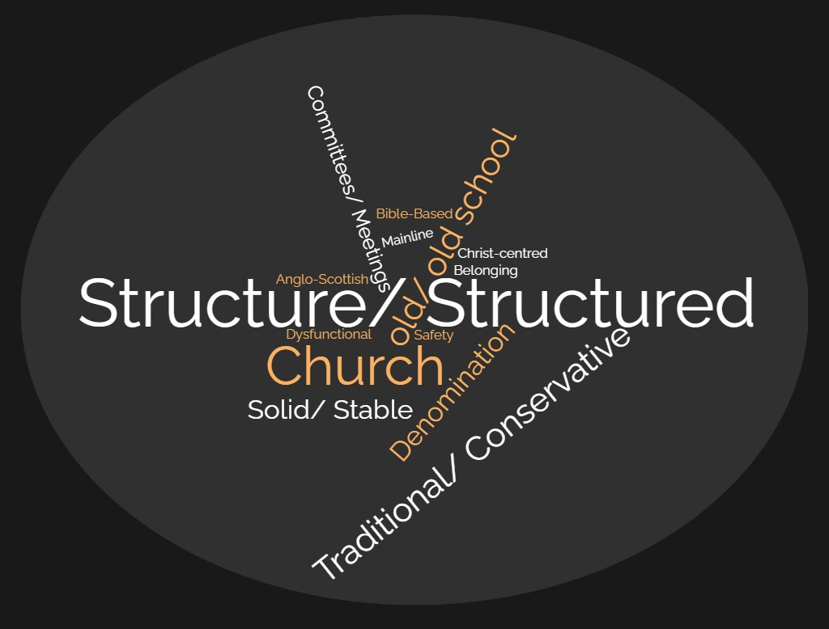

Words around structure and structures had the greatest commonality.

The more ‘logical’ response ‘church’ was common too.

Old, old school, traditional and conservative dominated the next tier alongside solid and stable.

Word Cloud 2: Presbyterian Minister

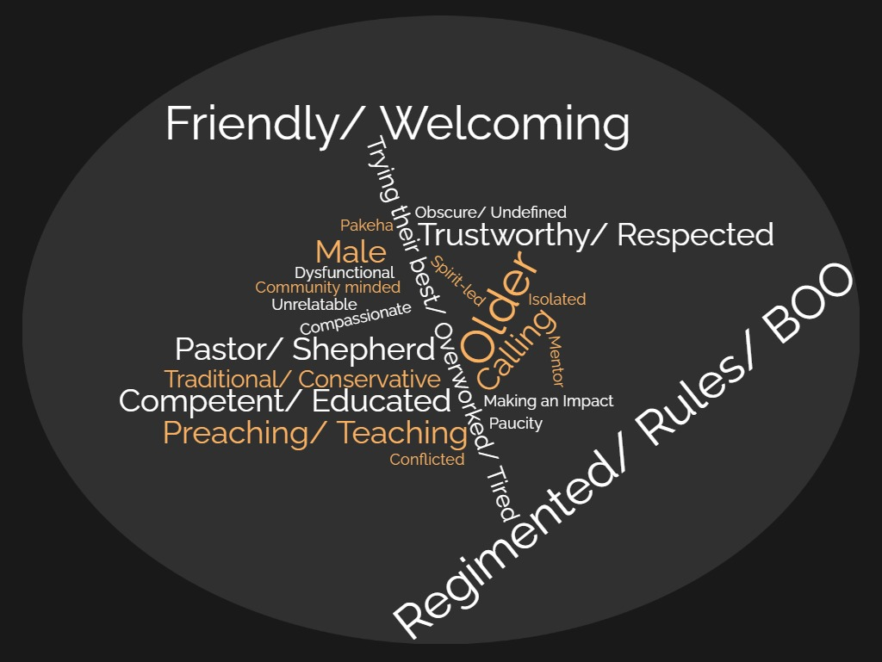

Friendly and welcoming type words dominated the results for Presbyterian Minister. However, that is also closely followed by words around rules, regimentation and the Book of Order.

Word Cloud 3: Presbyterian Worship

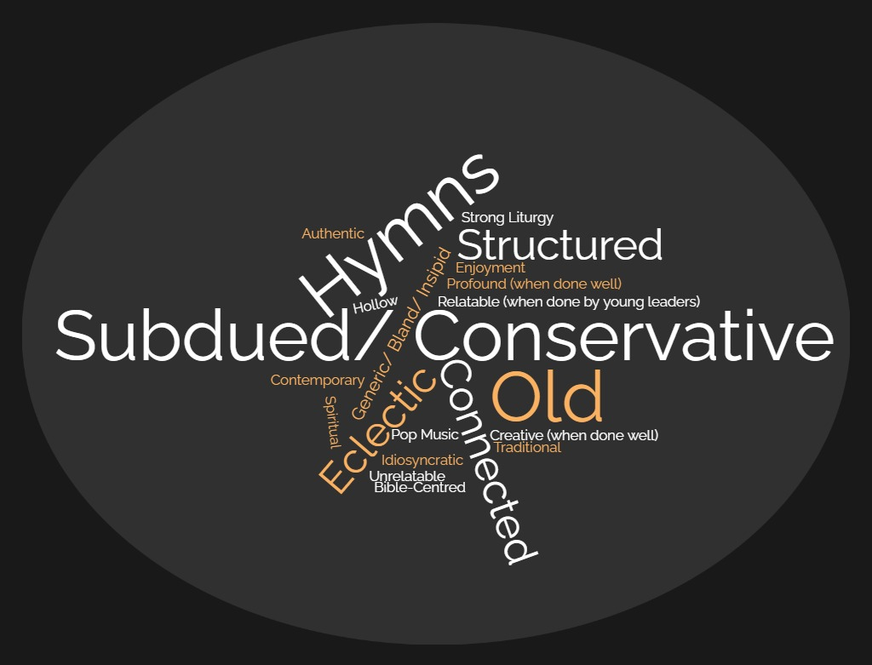

Impressions of Presbyterian worship were dominated by words around reservedness, subduedness and conservatism. Hymns also featured heavily. This was followed by words related to ‘old’. The next tier included eclectic, structured and also connected.

Word Cloud 4: Presbyterian Culture (Includes words from adjectives question)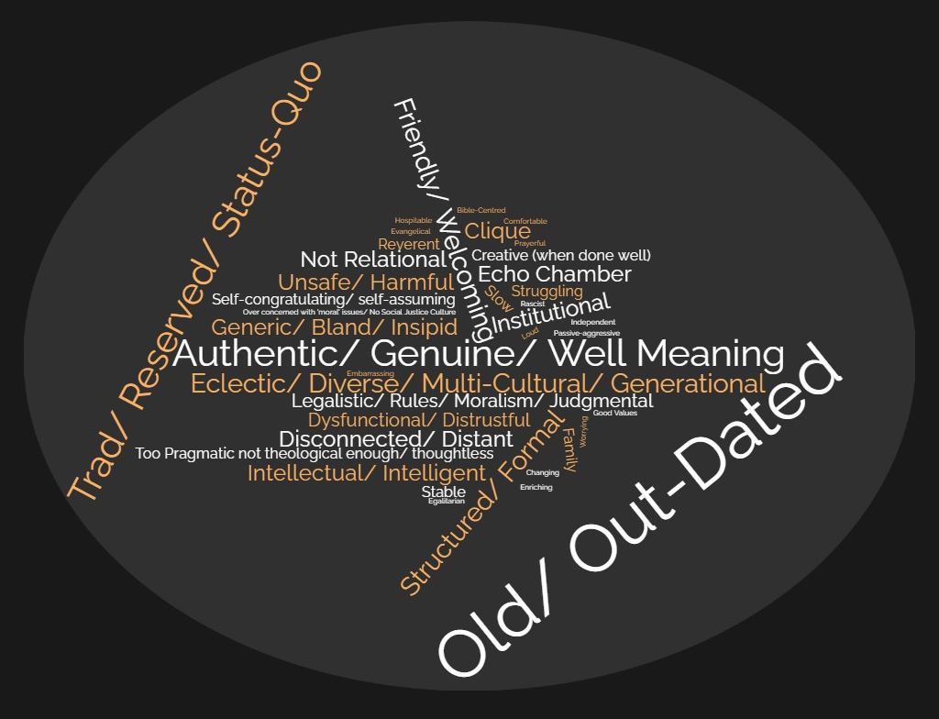

The word association mixed with the listing of adjectives around Presbyterian culture were dominated by words connected to being old and out-dated. These words were predominantly viewed as being an unwanted trait. This was followed by traditional, reserved and status-quo. On a different note, authentic, genuine and well-meaning were the next most common.

  - Abstract Concept Association

The following pie charts show us the raw and instant reactions of participants when grouping the Presbyterian Church within an umbrella concept.

Pie Graph 1: What Political Party is the Presbyterian Church

The National and Conservative party dominated the participants perceptions (80%).

Pie Graph 2: What Music Genre is the Presbyterian Church?

Pie Graph 3: What Communication Type is the Presbyterian Church

Pie Graph 4: What Radio Station is the Presbyterian Church?

Summary Statement

Although abstract these results communicate a picture of how the interviewees picture the Presbyterian church. The most stand-out perception is that of the church as being politically conservative (80%). This gives an interesting window into the perceived culture of the church. Whether or not the participants align with centre right and conservative values was not ascertained. However, statistically Millennials and Gen-Z tend to be more left-leaning than previous generations. Could this illustrate a conflict of values, or at least perceived values, between Presbyterianism and these generations?

Comparing the Presbyterian church with a genre of music gave interesting perceptions that tended to swing towards traditional and more conservative sensibilities. RNZ National and Newstalk garnered 19% each, as did The Hits. RNZ National and Newstalk are both speech-dominated ‘educative’ radio stations that tend to attract an older listenership. The Hits (formerly Classic Hits) tends to cycle ‘hit’ songs from decades past.

Overall, the comparisons gave an impression of something that is out-dated, traditional, conservative and somewhat ‘quaint.’

  - Metaphors

The following is a collection of metaphors or illustrations given by participants to describe the Presbyterian Church in their own perception.

P3: Maybe something like an open Bible… Yeah. church building. Maybe like some sort of picture of like, older people and then families and then yeah, that shows that intergenerational side. Yeah. Maybe a cross.

P5: I was thinking, I don't know if this fits in all parts of a metaphor, but like an old slipper. [raucous laughter]… It's like, it's comfortable. It's safe… Yeah, um it's old school, but it's also useful and solid, you know?... So yeah, all of those things about it. I don’t know how far you want to take that metaphor. Yeah. Yeah. An old slipper. Still good though.

P6: I would describe it as a canoe in the middle of a river. And everyone's rowing differently, in different directions. And I don't see that as a good thing or a bad thing. But like, Yes, that's just what it is. And I describe it as that, because we do have such a broad view of how to be church and what that looks like, and what's accepted and what's not accepted. That we do seem to be stuck in the same place… And the currents directing us more than the people in the boat paddling is. The current being like, society, I suppose.

P9: Um, [pause] think about a house that has good bones… But it has had a number of owners. And they've all tried to modernise it in really awkward ways. And so, what you're left with at the end, is, is plumbing that doesn't quite make sense. An extra add on that's sort of at odds with the house and isn't aging with the house very well. Yeah, it has some nice quirks and nice character. But it's tempting just to strip it back. And yeah, get rid of all the extra stuff.

P10: I don't want to be too negative because I think there is hope in this, but I think it is a bit of a teetering tower on the verge of collapse. In a number of different areas. And I mean, the good thing is it's a biblical image. And this is imagery of, you know, the potter reshaping the clay and using the materials of a destroyed building to build something new. So, I haven't given up hope in the Presbyterian Church, but increasingly ah I feel like it needs to crumble and needs to dismantle in order, for some of the change… to happen… It's like the building's tottering. And our focus is on our let's build this new ensuite, or let's build this balcony, which has these kind of like missional communities… So, it's, it's like, we're trying all this new stuff, but there's no longevity or sustainability. Because the fundamental structure, the structural integrity of the building is not good.

P11: Ah I guess a hospital with two different queues, right… One queue? You fit in boxes and you get straight in and are accommodated quickly. Yeah. And the other queue you have to answer a lot of questions you and not sure that you will get let in. And you're treated quite differently.

P14: I would describe it as is like a geriatric pirate ship. Right. [laughs] And, you know, but also this pirate ship that's kind of lined up in the battle ranks with a modern navy. Right? You know what I’m saying so like, yeah, they've got these old cannons, got these old dudes on the on the boat. You know, they can't even really raise the flag because they're so tired. It's moving slow. But they think that they're in the battle… and that they're ready to, you know, that they're there are sea worthy to line up with everyone else. And it almost prepared to be the flagship for this Armada that's going forward. We're, yeah. I think it was like this Galleon ship. That's yeah, you know? Yeah, these beautiful big sails. That look great. Yeah. But they can't man it properly. It's puffing under some wind in the doldrums and everyone else is just honing ahead of them… I’d also say to that metaphor, there's no captain on the ship. Yes. No, there's no captain. There's a lot of fighting about the captain and which direction they're going. Who gets to steer?

P15: A dysfunctional family.

P16: Think it's like a treasure chest at the bottom of the ocean. That not a lot of people see or think is important because on the outside, it's all barnacled and covered in dirt and sand and what have you. So pretty old and non-appealing on the outside, and when you get up close to it, you might get scraped or, or whatever. But inside, like the real guts of it is more than what you would want in a church in terms of like, being biblical. And honouring God's word is God's word and focusing on that, and trying your best to live as God has intended. There's the most we could get out of this life.

P19: A city on the hill that everyone has turned away from. So, it comes from a song from casting crowns. So basically a city on a hill and the story goes basically that the city had it’s soldiers, had its poets, had its King, had its poor people and stuff. But like as time and generation went on, they all starting turning away and started turning on each other… because basically the soldiers thought the pilots were weak, the pilots thought the dancers were like basically into themselves type of thing. And so, they all turn away and they all go their own separate way type of thing. But, yet it was the poet's who gave the soldier strength to defend the city. Yeah, it was the dancers that actually gave poets like their inspiration. Yeah, it was listening to the poor man or what he had to say through his life experience kind of thing. So, it's meant to be actually that we're meant to be all connected actually all supporting one another. But, as time goes on, it's about yet our differences are what we don’t like about each other when we are mean to be helping each other.

A majority of the metaphors gave a sense of something that is either broken, dysfunctional and/ or directionless. Nb. not everyone responded to this question.

- Open Interview Findings, Synthesis and Discussion: Re-humanising, Re-leasing, Re-Energising and Re-focusing.

The above ‘re’ words are devices to guide us. Each word focusses us to a series of mini-themes that have come from these interviews. Some of these themes are unsolicited trends from across interviews and others have been reflections on themes solicited via the template interview questions. When a theme is unsolicited it will be identified as such.

- Re-humanise

the one thing that you want to change is just more care for the people than for the structure, like the structures important, but more care for the people than the structure? (Participant 18)

IMPORTANT: To re-humanise is not to suggest that the PCANZ completely lacks humanity. Instead, it is a verb that encourages us to intentionally and thoughtfully re-invigorate connection, openness, empathy, and warmth in the Northern Presbytery.

Jesus commands us to love God, and love people as ourselves. This is the law in sum. To love each other is to desire the good/ best for each other and to make every effort to be hospitable and live in harmony with each other, despite our differences. In order, to be deep Christian community Pohl states that we must warmly and sincerely practise; gratitude, trustworthiness, truthfulness (in relationships) and hospitality. These are the virtues that develop healthy culture and community.

To re-humanise is to re-arrange and re-think our structures, our cultural emphasis and practices in order that Pohl’s list of virtues enable us to love people whilst honouring and loving God. As Jesus would encourage us, “The sabbath was made for man, and not man for the sabbath.” Our structures and processes are to serve the goal of loving each other and God. They should not exist for us to be subservient to them. We are to hold ourselves accountable for practices which develop and deepen Christian community and healthy, authentic, trusting and open relationships.

Welcome & Reception

- The Positive

… of my experience of the two Presbyterian Churches I've been to. The one resounding thing is that the people that are in the church tend to care a lot about people visiting or like families … everyone was always like, wanting to make sure we felt welcome, that people were always engaging with us about our kids, and like making sure that you know, there was something for them to do etc. … But the thing we love the most is that all the people talk to you. Yeah, ask you questions about your family. And it's never judgmental…. So that's my positive experience of the Presbyterian Church. (Participant 3)

Over 90% of participants commented on the Presbyterian church as being welcoming and friendly. There was a perception that upon entering a Presbyterian church you would receive a warm welcome. This is an encouraging percentage.

- Areas to Grow into

Although the participants saw the Presbyterian church as welcoming they wanted this to go deeper. For 58% it was communicated, in one way or another, that the church is only welcoming to a point. It was also noted that the Presbyterian church lacks deep community for these generations. It is a place of connection but it only goes so deep. There was a sense in which these generations desire embedded and deep community yet the culture of the Presbyterian church did not quite hit that mark. Some commented that it was a one hour a morning Sunday community.

    - Demographic Paucity

One reason for this perception of lacking community is demographic paucity. It was mentioned by a good proportion of participants that those in their twenties to thirty-somethings are thin on the ground. There was a sense that there was a losing battle as there was not enough critical mass of these demographics to sustain a sense of generational community.

Connection, Relationality and Stance

- The Positive

Of the candidates 68% gave unsolicited responses that communicated either a love, affection, sentimental warmth, or sense of family towards the Presbyterian church. Admittedly, within that 68% there were many with mixed and conflicted emotions. One participant profoundly said,

I think going back to the family comparison I made earlier that the more I talked, the more angry I'm starting to feel. Yeah. But it's, it's, it's kind of frustration. Yeah, because I actually care quite a lot about the Presbyterian Church. And I think both of those things have surprised me a little bit in this conversation that I haven't really been a part of one in [omitted] years. And I've had all kinds of varied church experiences since then. But while it's easy to critique, there is something in me, that is proud, I guess, to have been a part of it and to, you know. I would consider being a part of it again, if we found the right place. That yeah, it's that uncle that you don't really want to talk about. And that you really hope they're not going to be at the party and they are at the party. Then at the end of the day, you're like, I'm really glad they were at that party. [laughter]. (Participant 9)

- Areas to Grow Into

    - Relationality

Across the interviews, in one way or another, themes indicated a dissatisfaction with the level of empathy, spirit, openness, deep connection and relationality within the Presbyterian Church. Some left the church to find this in other churches, or incidentally found it elsewhere and did not look back.

58% of those interviewed spoke of a sense of the church as not being relational enough. That there is a sense of distance, closedness, clique-ness, and standoffishness. Some spoke of this making it hard to have deep connections and to have a deep sense of a community that ‘has your back.’

    - Moralism, Rules and Judgmentalism

Perhaps instrumental to this is the perception that the Northern Presbytery is a culture in which people are subservient to processes, rules, judgmentalism and legalism. 63% of those interviewed gave some sort of unsolicited account to that affect. At least 47% of the candidates noted, without solicitation, that to fit into the Presbyterian church they felt like they needed to have the ‘right’ beliefs and that there was little room to manoeuvre. Others saw this preoccupation with rules and/ or moralism as being severely detrimental to the church moving forward in a timely way as an institution. One participant said,

But it's perhaps very easily hung up on rules and regulations and red-tape and people want to do good. Like they want to be involved in these social ministries and to serve and to mentor to do all these things, but they either don't know how or they're too tired. Or, yeah, or under resourced or don't know how. They don't have the pizzazz to have people rally them together to network. Let's do this. And to focus on the most important thing is loving the Lord and loving people. and it doesn't matter what colour; you can choose… of the seats. Let's not spend hours on that. And let's just go and do that. So, I think because there's a lot of tape and formalities per se to the Presbyterian Church, it can be a little bit standoffish or hard for people in our general culture to fit in or feel like they belong, because it's quite foreign... So even though the, the Presbyterian Church wants to be really genuine, and to be welcoming, and to connect people, and some are great at that. But others I think… get held back by all that other stuff.

    - Closed versus Open Stance

In connection to the sense of needing to have ‘right beliefs.’ There was a perception that the Presbyterian church’s is closed rather than open. 47% gave unsolicited responses around their experiences and perceptions in this vein.

I know that some churches have it the other way where the teaching is not that great, but the congregation are very strong in their faith and they do community really well. Whereas like, yeah, I feel like it's the other way round. Well, like for some, but as a general. I don't know if it comes from that reservedness maybe. It’s like [Presbyterianism], almost very private. Maybe, but then I'm very open. So, that might just be my knee jerk reaction. (Participant 15)

Closedness and openness was seen in both how people related to each other, how beliefs were held and communicated and also how church leaders responded to issues and people.

On a positive note, at least three participants talked of their church’s journey towards openness and space for difference.

P18: No, I mean, [minister name omitted] definitely gives a commentary on what's going on. [They] make an effort for that. And you kind of get an idea of where [their] stance might be. Yep. But it's not like, you must believe the same way as I do.
Me: Yeah. It's good. It's reasonably open. Yeah.
P19: … We have now sort of lost those five people that did have a big stance but weren't able to correctly communicate and actually discuss. Together to come to what Christ might be talking to us about it.
Grant: Good. Yep. So, [they] do talk about social political things. But in a healthily open way.
P18: I think so. (Participant 18 & 19)

And so like [the minister] will discuss that, and [the minister] will like research and [the minister] talk and like, they'll have a chat and stuff like that. So, I guess … trying to get them out of that habit of like, okay, we'll just we'll just do whatever you say. Because, you know, that's not, that's not what he wants. So I am, I guess with with [Minister name omitted] as well, he's really good in like, having those conversations… It is more as I think it's opening up a little bit more, at least at my church. It's not necessarily just like, you have to do what we tell you to do. (Participant 2)

However, there were two stories where a misuse of influence from leadership caused two younger people to feel the pressure of promoting certain viewpoints during Presbyterian forums. For one person, this was instrumental in their leaving the church. They felt pushed into taking a position and presenting it. Another person did not feel pushed but shared of feeling ‘over-guided.’

[I] had a very brief chat with [minister name] I think. And, and there was like, I think looking back on it… I don't think it was like I didn't view it as pressure at the time. But now that I'm looking back at it, there was definitely like a kind of nudging to be like, if you don't have this view... Do you know what I mean? But yeah, luckily, I agreed with that at the time anyway. So, I didn't feel like I was being pushed. Yeah. So, and I know that like, if, if I had disagreed, or if I had stood up or said something like, then there would have been issues there. (Participant 2)

Additionally, a small percentage (21%) noted disrespectful derogatory language towards certain demographics and viewpoints coming from leadership.

[T]here was like, willingness to talk, to go through the motions. Making room for that, but not really genuine… or like not heartfelt… I recall a conversation I had once with a minister where it was like said that I felt that the way something was delivered was in a way that would… chase people out, certain people out of the congregation and the response was that they ‘stand by what they said.’ And to walk away… So, it wasn't like… hey you know, if they hadn't walked away, I would have said it wasn't what was said, it was about how it was delivered… But there wasn't a great deal of willingness to listen. (Participant 11)

And I think there was, for a more concrete example, the way… people who didn't fit the idea of what a Christian should be were referred to, was often in really derogatory mocking phrases. Even just like, artists, or people into the arts, we're often kind of derided. Yeah, from the front. And I just didn't like that… That kind of mocking, smug tone. (Participant 9)

This sense of closedness was also felt outside of the pulpit. 32% felt that elements of ‘success’ were measured in the Presbyterian church by believing the ‘right’ things. There was expressed as a feeling of needing to ‘believe everything we believe.’ Participants felt there was no room to move.

But there doesn't seem to be much of a culture of compromise. It seems that what you believe is the correct belief, and I'm going to try and get everyone else to believe the exact same thing as me. And so, it doesn't, it doesn't feel very Presbyterian at times. It feels more congregational. (Participant 6)

My impression was success was having the right beliefs on issues. Gospel and your opinion on current issues. It’s a relief when I meet people [in a new context] that allow for messiness and disagreement. Because if I do come to agree I’ll get to grow to it genuinely. Everything had to be kept tidy and if you believed the right thing then you were doing well, you were an ally. There was a quite a few of us in our age group who were struggling with figuring out what we believed on certain issues of the time. We felt that there was no room for conversation [or] discussion. The answers were set and either fall in and be accepted or be more of an outsider. (Participant 7)

The sense of how views are held and communicated led 47% of interviewees to perceive the culture of the Presbyterian church as being somewhat closed, lacking theological space and sometimes dogmatic. These nine participants volunteered what were unsolicited perceptions.

    - Issues Elevated above the People they Affect.

53% communicated, unsolicited, in one way or another that the perceived issues were elevated above people.

P13: We were at [event name omitted]... It was around the LGBT… We were discussing the topic. One parent stood up and said, because I think at the time, they needed to know the Presbyterian Church's stance as others …Catholics had come where they stood and what not. And so, they were asking as a church, where did we stand. And a mom stood up, and she shared how her daughter was a part of the [LGBTIQ+] community. And she would hate if we took a stance against it, because it would mean that her own daughter would not you know, would not feel comfortable to worship at their home church. And one… another person stood up and was like, ‘I don't care about your daughter’. So that was like how are we Christian and how are people saying this to each other in the church context? No order was called. He was allowed to finish his topic with whatever he was saying. Sat down and more, woah, like that was kind of the beginning to opening up a can of worms, like, there was like, people were really like ridiculing those in the [LGBTIQ+] community.

Me: In another interview, and well, a lot of other interviews I’ve heard it said, and whether you agree or not that that’s fine. I’ve heard it said that they feel like the Presbyterian Church, in some ways, the culture is more concerned with the issues than the people that those issues actually affect.

P13: Amen! I totally agree with that. Grant. Yeah, that’s what I was thinking. What uh, what is that? What are we called today as a people for? (Participant 13)

Similarly, in another interview, a participant was asked what one thing they would change about the Presbyterian church.

P7: To make the church more empathetic, to be not be so fixated on issues but on the people underneath who are probably already dealing with said issues. Too much on do this or do that whilst ignoring the people who are underneath the issues. (Participant 7)

Some participants who themselves hold more traditional views also commented on the tone of how issues were approached. The following quote from P8, who is no longer in a PCANZ church, echoed some of those voices

My church I would describe as Evangelical, but it's different kind of evangelical, but we're not going to have the same approach. Yeah, yeah. Sexuality being one of many examples where we were evangelical, we believe in Christian marriage, but yeah, like, we're not gonna have the same … conversations and draw the same judgments and make people feel inadequate. (Participant 8)

What was instructive about these conversations was that a majority of the participants (regardless of whether they were more ‘conservative’ or ‘progressive’) gave room for there to be different views. For these Millennial and Gen-Z participants, there was an openness for difference. Overall (with obvious exceptions) there was a sense in which many were over the ‘culture wars.’

I would want to remove the angst… I would want them to not worry about society and the changes in society and to not get swept up and stuff, but to care about people around them…. And be proud of their history. (Participant 9)

Social Issues, Social Justice and Politics

- The Positive

On a positive note, 94% saw that local Presbyterian churches were trying to make a social difference, but most recognised that it was not an integral part of our current collective DNA. There was talk of being limited by resources (time and money) and often it was a small number of people doing a lot in local churches.

- Areas to Grow Into

73% without solicitation intimated, in one way or another, that the Presbyterian church needs to get out more into the community. This was in contrast to a current mode of inviting the community into our spaces. This meant having an ear to the ground regarding what needs are on your doorstep.

P14: Whereas it's actually going into whatever community is around you. For us, you know, I think of [suburb omitted], even here like people, suicide is rife, divorces. So it's about, you know, walking alongside and in some ways what you do as a church may not look different… I mean I consider mission is… basic Christianity… It's the kingdom of God like we were to bring people into the kingdom and it's going mmm like I might not agree with what you're doing. But I love you because you're my neighbour. And that's what I'm called to do. And I'm going to support you, you know… I'll give you a meal, I'll help connect you with other people in the community. But I might not agree with what you do… not having an agenda. Like my agenda isn't to get you in there. It's just because you're my neighbour. And who's my neighbour? Well everyone… but ultimately, I'd love you to come into the kingdom and live follow the way of Jesus, because that's the way to live life and life to the fullest. (Participant 14)

Similarly, in another interview, a participant was asked what one thing they would change about the Presbyterian church.

P8: [That] there's more outward. Looking, but not sorry, not just outward, looking. Outward acting like actually. real genuine. Community engagement and organic outreach … Like, the average Kiwi doesn't care about the Book of Order? Or? Or how many hymns you have on a Sunday morning?... I'd say this is a lot of kiwi churches. How much do you engage just with, like, even the neighbours and the community? In your neighbourhood to start with? (Participant 8)

79% of interviewees believed that the Presbyterian Church does not give nearly enough attention and action to social issues and they want to see more.

P1: I know, the Presbyterian Church does a lot you know, does do work and, in feeding the poor, etc. But it's not the first church I think of. If someone were to criticize, I'd be able to go oh, actually they do…

Me: What are your perceptions of how the Presbyterian churches, engage with social and political issues.

P1: “Yeah, I mean I have to [put] it in the middle. I feel like there's been stuff about, you know, the whole look, there's an inequality thing, and this is terrible. And there's a lot of people sleeping in cars. You know, I also have seen every time there's this big statement, from all the churches, there's a couple of Presbyterian names… But, yeah, it's like a solid kind of C-, you know. Maybe a pass?” (Participant 1)

Similar understandings were expressed by another participant.

P5: It's not like a big social justice church, like [other denomination church name omitted] or whatever. They've got the like, social justice arms and you've got like, counselling or whatever. Other things?

Me: Do you think the Presbyterian church, as a whole, could do better in that?

P5: Yeah, definitely. (Participant 5)

…I mean, the Sallies they're known for that. It’s what people associate with them, they'd probably say, yeah, conservative theologically, but it is at least known that the Sallies are invested in the poor, and are putting their money where their mouth is with the poor. With the Pressies, I think we're by and large an upper middle-class denomination and we always have been, like you look at where we are. We don't have a Presbyterian Church in [name of local low socio-economic suburb]. But we’ve got one in [local very high socio-economic suburb], in [another local very high socio-economic suburb], in [another local very high socio-economic suburb], in [another local very high socio-economic suburb], and in [another local very high socio-economic suburb]… So we've grown where the Presbyterian settlers had moved, and those were predominantly white, middle class areas… (Participant 10)

When it came to the profile of Presbytery or the national church there was very little awareness amongst the participants of any social action happening.

I think we take too long to engage in that [social issues]. Like, we don't engage fast enough for our voice to either make a difference and the actual issue or we're forced to basically because we're taking too long that we already make our stance with how people already perceive the church, as what they think we will be taking a stance on. (Participant 19)

There was also discussion around the type of issues the Presbyterian Church was perceived as focussing on. 53% indicated that what they see and hear being talked about ‘from the pulpit’ are typically ‘individual moral issues.’ There appeared to be less engagement with bigger social structures and issues like the housing crisis, mental-health or child poverty. If these things were mentioned they were hardly spoken of ‘from the pulpit,’ whereas typically ‘individual moral issues’ were.

It was overwhelmingly obvious that everyone who was interviewed desired to see more social good come from the Presbyterian church. There was a desire to see a grounded, local, Presbytery and Nation-wide movement on social issues. There was even talk of finding common ground amongst the theological spectrum of the PCANZ. The question that was raised and one that is always raised, how and who?

    - Presbyterian Support Northern (PSN)

Another striking discovery (that may help answer the questions above) was how many interviewees had little knowledge of PSN. It became apparent that a high proportion of local churches do not communicate to their congregations about this organisation. There is a sense that PSN has become divorced from local congregations, or at least their consciousness. Of those interviewed only 31% were aware of PSN. Among this 31%, was a vague awareness that did not go beyond knowing that they are a ‘social agency’ of some kind. Only 2% of the participants could speak with any clarity on who PSN are and what they are doing. Once explained many felt that it would be great to re-kindle a healthier, more connected relationship between the local church, Presbytery and PSN.

Presbyterian support has just got on and done their own thing. And then they're doing some great work. But the relationship with the church. I guess it depends where you are around the country. But it tends to be very tenuous. [T]he more we can profile Presbyterian support, or like, we've got the Presbyterian church school network… we've kind of disowned them we haven't owned our investment in either social justice or in education. And, and as a result, the Presbyterian Church is becoming increasingly idiosyncratic. We're just living in our own little bubble, trying to do our own little thing. (Participant 10)

Possibilities and Suggestions for ‘Re-Humanising’ the Northern Presbytery

As introduced earlier, the need to re-humanise involves a verb that encourages us to intentionally and thoughtfully re-invigorate connection, openness, empathy, and warmth in the Northern Presbytery. It does not to suggest that the PCANZ completely lacks humanity.

Facing ourselves can be hard. It was encouraging that the majority of those interviewed had some manner of goodwill. For many there was a hidden sense of warmth or love towards the Presbyterian church that would burst out at points. The standout feature of these interviews was that a great majority stated or recognised that the culture of the church is well-meaning and trying to be loving.

However, it was also apparent that a general sense of dissatisfaction, disappointment and disconnect was present with the majority. This is ultimately evidenced in our churches by Millennials and Gen-Z ‘voting with their feet.’ Of course, it needs to be acknowledged that in this kind of project we can expect human nature to home in on what’s wrong. Equally, as re-formers, we want the Presbyterian church to be the best ‘self’ it can be. That involves honest self-reflection.

Practices that can re-humanise the Presbyterian church are paramount if we are to connect to Millennial and Generation Z. There are some obvious and constructive things that can take place. However, the spadework of cultural change is harder to implement. That involves both goodwill, intentionality, self-reflection, and openness by church leaderships, congregations, and Presbytery. The following are some reflections.

- Re-thinking how we Relate and Hold Positions

The interviews revealed (unsolicited) that 63% of participants experienced encountering perceived instances of moralism, legalism, and judgmentalism. 58% mentioning issues of cliquey and shallow community. 47% had concerns around how we hold and communicate views. 53% saw the Presbyterian church as having a culture where structures and beliefs appear more important than people. 21% heard derogatory language about segments of the population coming from leadership. These are the kind of statistics that we need to listen to.

Whether or not these perceptions are incidental or endemic, as churches and leadership we are tasked with ensuring that our communities are healthy. Having ‘progressive’ or ‘traditional’ beliefs is not the primary issue. Some of those who have commented on their uncomfortableness with their own Presbyterian experience maintain traditional beliefs. This is not simply a ‘progressive’ versus ‘traditionalist’ thing.

If we are to re-think the culture of Presbyterian churches, regardless of our theology, we need to give careful consideration how we talk about others and sections of the population. A sure-fire way to push out Millennials and Gen-Z from the pews is to speak negatively of others or to belittle other worldviews.

Further to creating a sense of openness. Is there room for doubts without guilt, asking questions and not feel shut-out because of them? Can we allow for difference of opinion? St. Augustine speaks into creating a culture that breathes and is open: “In essentials, unity; in non-essentials, liberty; in all things, charity.” If we are to be true to our Presbyterian roots, and to cultivate a healthy open culture then dogmatic attitudes, especially around peripheral issues, should be avoided and their should be openness for difference of opinion, discussion and healthy discussion.

    - Eldership Level

Eldership teams are encouraged to be highly self-reflective as well as monitoring and reviewing the culture of their parishes. In your pastoral work talk openly and often to members and congregants in every generation. Identify sticking points and celebrate that which contributes to healthy community and address that which does not. Aim for a healthy and open culture that is outward looking and where belonging precedes believing.

    - Presbytery Level

At Presbytery level we need to start intentionally equipping ourselves. We need to face how we are connecting to, and offering a space for, Millennials and Gen-Z. Are we a church that ‘leaves the 99 for the 1’?

Recommendation:

As a church our DNA has been that of education. Regional meetings need to be engaging with issues of generational differences and culture via education, reflection and prayer. We need to invest in quality guest speakers in the field.

- Re-sourcing Social Good, Social Justice, Environmental issues and Re-Connecting PSN to the Wider Life of Northern Presbytery

The PCANZ has officially recognised five faces of Presbyterian mission. Those five faces are:
- Teaching and nurturing people in Christian faith
- Loving service responding to human need
- Proclaiming the gospel
- Seeking to transform society
- Caring for God’s creation

From the interviews there is a general perception that we are doing the first face relatively well but that local churches are not resourced to perform the other four faces adequately. Additionally, there is a recognition that Northern Presbytery has no cohesive voice around social issues. On top of this there is a lack of awareness of the work of PSN.

It would be wise for the Northern Presbytery to invest in promoting, establishing, resourcing and performing social and environmental good at local and Presbytery levels. The Northern Presbytery needs to actively promote PSN. Mobilising the Northern Presbytery for the poor and marginalised, for good in our society and the environment is both a theological and missional imperative. Having a voice and being proactive may also result in drawing in, sustaining, and connecting younger generations. This could also help to re-humanise the culture of the Presbyterian church.

We have a relatively underutilised Mission Enabler and mission fund. We have a resource in PSN who are also significantly underutilised and disconnected from many local congregations. There is also the Presbyterian School’s network. They are making efforts to invest in local social good alongside PSN. There is momentum occurring on the fringes of Presbyterianism. Is it time to gather momentum together and unite our voices?

As a minister I am aware of the demands and strains of ministry. We are all tired. This is why I believe the way forward for church’s is partnering with existing organisations, so as not to reinvent the wheel. On top of this there are funds out there for social good. Trusts and grants exist. We need to think smarter and look at resourcing/ employing people to be connecting church, community and social need. Start small. What is one local issue that you can play a part in?

    - Eldership Level

I encourage local churches, Ministers, and leadership teams to continue to listen with intention in their communities.

- What is happening in your community, where is God working and can you play a part to enable your community to flourish?
- Can you partner with other organisations to help this to happen?
- Are you aware of the work PSN is doing around you?
- Have you taken advantage of the Northern Presbytery Mission Enabler and the available mission funds for projects that do good in the community and environment?
- Have you explored available funds out there?
- Has your church embraced and moved towards being an eco-church in practice?

    - Presbytery Level:

Recommendation: That Presbytery Council consider allocating a protected percentage of its mission funds to projects and initiatives that specifically address/ highlight social inequality, social issues and environmental issues.

Recommendation: That Presbytery Council consider refreshing our current missions’ funds team by making a concession for non-elders to be involved so that at least 50% are Millennial and/ or Gen-Z.

Recommendation: That Presbytery Council actively embrace and action the GA 2022 decision to be an eco-church partner by tasking the Northern Presbytery Mission Enabler to report on how this is priority is integrated with their workflow.

Recommendation: That Presbytery office consider holding and actively advertising a database of available funds for social/ environmental good programs etc beyond the Northern Presbytery mission funds. That the Mission Enabler role and Presbytery gatherings include training in awareness of and writing of external funding applications.

- Re-Lease and Re-Energise

P14: What is the biggest thing that I would want to change? [A]part for that other stuff we talked about [with] the Book of Order offering clarity… that would need to change in order, for my top priority. Which would be having under 40s make decisions… I mean, like people who are willing to make decisions and take risks should be in leadership… So, I think and that would be amongst congregations as well as yeah presbyteries … And it's like there's a time where you outgrow an institution or an institution outgrows you. And I think that we need people who are going to push the institution or organisation forwards. So that it outgrows people, rather than those people outgrowing that institution and moving on, which is generally what is happening now. (Participant 14)

IMPORTANT: To re-lease and to re-energise is not to suggest that the PCANZ is ‘held captive’ or lacking energy. Instead, it is a verb that encourages us to intentionally and thoughtfully re-think how we can proactively broaden those making decisions in the Northern Presbytery, and how we can add to our current energy levels by bringing younger energy to the Northern Presbytery.

To re-lease is to intentionally pass on the baton to successive generations in order that our way of being is relevant to those coming up. To re-energise is to wisely use the energy of younger generations so that they are instrumental in shaping a way forward.

The type of words and perceptions that tended to dominate the word association and the majority of discussions were stale, old and risk averse. Participants saw a need for change. It was hard to ignore the general impression from an overwhelming majority that the Presbyterian Church is struggling. What and how to change is the burning question.

Yeah. And there seems to be a growing culture of… a yearning for change. Yeah. But no one quite knows what that change should be, what it should look like. But there's a yearning for it. Yeah, I think that also ties into the inability to move. Because someone wants to change ‘this way’. But somebody else wants change ‘this way’. And so, then you're like, well, we can't do both. So, I guess we do none. But there does seem to be a yearning for change. But hopefully not change for the sake of change. I think we might also be heading that way as well. Like, we're like, oh, something needs to change. We just need to change… I think, like, change for the sake of change isn't good, but change that's thoughtful and deliberate. That's good. (Participant 6)

Demographic Imbalance, Permissiveness and Empowerment

An apparent theme was the demographic imbalance across the PCANZ. Tied into this imbalance was the perception by some that change and permission to change was often hindered and/ or unhelpfully slowed down by process and a lack of imagination.

- The Positive

Me: On a scale of one to five how permissive do you think your experience of Presbyterian leadership has been for younger generations to do things?
P4: I would say it's pretty good. I mean, like, probably like three to four, like, just in my experience.

In the interviews it was apparent that some churches are permissive and empowering younger generations somewhat. There is also a reasonable recognition that on the ground many Presbyterian churches are quite multi-cultural and multi-generational. The obvious exception being the notable absence of 20-30 somethings.

- Areas to Grow Into

    - Demographic Representation Imbalance

32% of participants indicated (without solicitation) in one way or another that Presbyterian representation and culture across churches and Presbytery is particularly favoured towards older males, those who are Baby-Boomers (and older). Some added Pakeha or Palagi to their perceptions.

Participant 18 shared of their experience at a Presbyterian event,

There was this really powerful moment where one of the Pasifika leaders stood up and lamented on how they feel like the cast off. The younger brother who was just not listened to. And people were crying like, yeah, it was cool, powerful. And just like it's hard for us, because we're on the ground. We're not really in the higher levels or anything to understand how our brothers and sisters feel like they actually don't get a voice. And if they get, like, listened to it's token, and it's not actually taken on board… (Participant 18)

Another example came from a participant’s experience of KCML’s latest appointments:

But right now we still seem like a denomination that's run by palagi men… And that's pretty much what our church's been… but it doesn't look that way anymore. We're not only palagi men. It’s like KCML, we were waiting with anticipation with this whole new restructure, who was going to be hired? And then it's all palagi men… I guess we're missing the mark again, that people know why that's important. I don't know if they knew that. If they thought about it. This is a big standing issue and people at our [ethnic] churches were actually looking to see who is going to be there. It wasn’t what we expected. (Participant 13)

Unfortunately, PCANZ statistics do not delineate by ethnicity, so getting specific numbers on the ethnic makeup of Northern Presbytery is difficult. However, the Northern Presbytery 2021 statistics communicate that females (3403) make up a majority of church members by a ratio of almost 1.5 (2362 males). We are a predominantly female church.

Diversity has been on the Northern Presbytery’s mind for quite some time. A newly appointed Intercultural Facilitator has been an important step towards this. KCML recognise and have acknowledged the lack of diversity in their new configuration. However, the sense is that it is time for new representation across generations and ethnicities. There needs to be a concentrated effort to re-lease the Presbyterian church to upcoming generations and across cultures for the sake of our future.

    - Permissiveness and Agility

79% of those interviewed mentioned (unsolicited) that they perceive the PCANZ church to be both slow to change and resistant to change. This includes change at a local, Presbytery or National level.

I guess that's another thing about the culture is that I would say it is slow, it is slow to change, slow to accept change… like just it's very slow. It's like it can change. And I think it's starting to realize that it does have to because everything in this time, it just gets, it just gets faster and faster and everything is so rapid. And if we want to keep this generation and raise them as Christians, we have to be able to relate to that rapid change, there has to be a balance somewhere like you know, you can't, you can't have it all. You can't expect them to be able to adapt to the sort of worship style and culture and then not also accept what they need as well. (Participant 2)

The local church’s perceived aversion to change was a key factor that either caused some to leave the Presbyterian Church or to not look back when they encountered more agile and forward-thinking local churches.

P8: At the same time, as there [are] seasons and times to be in a different context. And so, it was after I'd moved [from Presbyterianism to another denomination]. I felt that, no, [partner name omitted] was right and [it was]a good decision. And our family has really flourished with us… if you make the way you've always done it the main thing you risk it not working? Yeah. Have you heard the analogy of the… Surf Lifesaving club. There's a surf lifesaving club that spends its time, rescuing people in the surf and from shipwrecks and things. And that's their focus… Over time they decide to spend more money on their own. The decorations and the repainting and getting the clubhouse looking really good. And then over time, they spend more and more time in the clubhouse rather than actually down at the beach. Before eventually, they just cancel any rescuing and they’re just a club… if you don't actually look beyond your own community and be willing to adapt. Then you risk being destroyed as an organization.

Me: Yeah, it's the sense of living for something that's beyond yourself… how do you think success is measured in the Presbyterian church from your experience of the culture and I guess what's communicated…

P8: …kind of preserving the way that that we do things… Like the Mandalorian, ‘this is the way!’

Me: [I]n the Presbyterian church, for you, how do you know you’re being a successful Christian? What does it look like?

P8: Where you keep showing up, turn up… But for those that have vision and get ideas of things that could work and want to try things it's frustrating because if success looks like doing things how you've done it and maintaining, then you're never gonna [move]… (Participant 8)

Some of those interviewed did indicate that they appreciate that the Presbyterian church is deliberate. There was much talk of not changing for the sake of change, or of chasing novelty. However, 79% of participants perceived the Presbyterian Church is far too slow to change and resistant to change. This resulted in missing out on opportunities or not moving forwards because of this.

Hence when a participant was asked what one thing they would change about the Presbyterian church

P13: The processes and systems, I love the Book of Order, but I feel like it's also like a hindrance to change within our churches. It’s a slow snail. We need change. We [have] to wait for General Assembly or make, you know… Go through all these rings of fire too.

Me: But even then, it doesn't necessarily happen in one assembly. You know?

P13: Yeah. ‘Deferred’. Yeah, that’s something I would love… And I think with the rate of the way things change in society, and if we’re so slow to make changes, we're just always on the backfoot. (Participant 13)

There was also talk of empowering the young in principle but clamping down when things pushed outside of the status-quo.

P12: But you know, working with the youth a lot it’s all of that… its hearing them but also creating opportunities for them to step up… we love… our youth like stepping up. [But] as soon as they step up, you know, we start criticising…

Me: And so it's kind of like, what I'm hearing is you don't want to just give them rein over everything, but at the same time, they need pockets or areas where they can… shape it… and for the rest, to appreciate it rather than to pull it down because it doesn't fit what it is that they want it to be.

P12: Yeah, what we're used to kind of thing… That's definitely what I'm saying, thanks. (Participant 12)

    - Risk Averse: Maintaining the Status-Quo

74% mentioned in one way or another that the Presbyterian Church plays it too safe and is dominated by a status-quo mentality that is risk averse.

P13: Yeah, how do you sum that up. The culture of the Presbyterian church?... I feel like we play it safe… we sit in the middle for a lot of things… so rather than creating real change and culture we just stay in the middle for everything and nothing happens. [We're] not leading change or [being] bold you know, like leading the way… [we] just sit and stay. And that's what I feel like we [are] as a denomination. (Participant 13)

Possibilities and Suggestions for ‘Re-Leasing’ and ‘Re-Energising’ the Northern Presbytery

To reiterate; to re-lease and to re-energise is not to suggest that the PCANZ is ‘held captive’ or lacking energy. Instead, it is a verb that encourages us to intentionally and thoughtfully re-think how we can proactively broaden those making decisions in the Northern Presbytery, and how we can add to our current energy levels by bringing younger energy to the Northern Presbytery.

If the Northern Presbytery wants to minister to younger generations today and into the future, now is the time to listen to and empower Millennials and Gen-Z. Now is the time to start giving greater representation to these generations, in leadership, in eldership, in sub-committees, in Presbytery workgroups, in employed roles or by simply listening and giving credence to their voices. It’s time to avoid tokenistic representation and truly listen.

- Re-Lease them and Adjust your Lives Accordingly

Apostle Paul famously said,

To the Jews I became like a Jew, to win the Jews. To those under the law I became like one under the law (though I myself am not under the law), so as to win those under the law. To those not having the law I became like one not having the law (though I am not free from God’s law but am under Christ’s law), so as to win those not having the law. To the weak I became weak, to win the weak. I have become all things to all people so that by all possible means I might save some.

To Millennials and Gen-Z become Millennials and Gen-Z. Aim to understand their cultural perspective and what motivates and leads them to flourish.

It is important that older generations do not covet power and influence. Instead, in wisdom, in acts of humility and grace, adjust to the lives of upcoming generations. Do not keep expecting them to adjust to you. Older generations must allow themselves to be led just as much as lead. Allow for new ways and new focusses, risks, and the inevitable mistake here or there. Take seriously their concerns and remember that a preoccupation with the pragmatic, practical and financial are not nuances of their generation. They were raised to be creative, adventurous, adaptive passionate and make a difference (maybe the ingredients needed for mission).

- Re-Invigorate by learning to say, ‘Let’s give it a go!’

If we desire to have churches that are connected to our local communities. If we desire to have churches that are breathing life and flourishing, it is vital that we learn to say, ‘yes’ or ‘let’s give it a go!’ A culture of ‘no,’ an unnecessarily pragmatic culture, a culture that is slow to try things and that is concerned with maintaining the status-quo is not one that will excite or retain these generations.

Additionally, if Millennials and Gen-Z do not feel that they are listened to they will be much quicker than previous generations to question why they’re there. They will vote with their feet and go elsewhere. Creating a culture where they are heard and feel valued is easy. This may involve focussing on solutions rather than problems, being outward looking, taking risks, walking by faith, allowing things to happen ‘differently,’ and to empower creative solutions.

- Presbytery Level:

Recommendation: That Northern Presbytery incrementally, systematically, and intentionally change the generational makeup of Presbytery Council. That by 2025 at least 35% are Millennial and Gen-Z.

- Re-Focus

Mmm, [pause] I would love I think, particularly with the Presbyterian Church, because it has such a long history… And I would really like to get past the last 50 to 100 years that we seem so obsessed with. And to explore some of the, the fullness of previous traditions and theologies. And I would love that. I think that's an opportunity missed. (Participant 9)

IMPORTANT: To re-focus is not to suggest that the PCANZ has completely lost focus. Instead, it is a verb that encourages us to intentionally and thoughtfully re-think how we can proactively evaluate our current worship practises and spiritual-formation as churches.

Are we creating worship spaces where these generations can connect to others, God and feel grounded? Are our practices dull, dry and lacking creative spark or on the flip-side are they overly entertainment/ consumer/ performance driven? To re-focus is to reflect theologically on our worship and structures by refocussing on the needs of younger generations.

Structure and Safety

There is much to love about the polity of the Presbyterian church. Many of those interviewed voiced their appreciation for the structures and systems (when working well) that keep the church from toxic hierarchicalism.

- The Positive: Re-Joicing

The general sense was that of the PCANZ system being solid, relatively safe and trustworthy (see word clouds 1, 2 & 3). Albeit, slow and frustrating at times. A handful mentioned that Presbyterian Ministers are educated and qualified which adds to a greater sense of safety.

I feel like the ministers of a Presbyterian Church are well trained. Yeah. In regards to like… [church name omitted]… which we've visited, Like… [it’s] someone's son who's been chucked into an internship… [T]hey might have gone to their own college. And it was like, three months training, probably mostly around how to do public speaking… I know, if I go to a Presbyterian Church, I'm gonna get someone like [names omitted]. You're like these people have gone through [proper training]? Because [they] have to do a Bachelor of Theology first. (Participant 3)

Words like ‘toxic’ were rarely used. A few even explicitly stated, despite their misgivings, that it was not toxic. One participant saying, “I wouldn't say it's toxic. I would definitely say, cultures of other churches are quite toxic.”

This may seem like a consolation prize, but it does highlight the heart of the Northern Presbytery. Our polity, although imperfect, has enabled us to stay reasonably safe from becoming toxic and autocratic.

- Looking Truthfully: Re-Thinking

What does it mean to be Presbyterian? This is a question that we must ask ourselves regularly. In its essence to be Presbyterian is to be a connected church, as opposed to a collective of independent congregations. Presbyteries and sessions exist to give oversight to congregations, empower healthy worship and take leadership.

In many conversations both in these interviews and in general PCANZ experience there is an increasing concern that we are becoming far more Congregational than Presbyterian. Of those interviewed at least 1/3 felt that the Presbyterian congregations have siloed themselves off with Congregationalist tendencies. There, was also a sense that the Presbytery (as a collective) has not been brave enough in implementing change. That we’ve been too hands off and scared to rock the boat.

Yeah, when we talk about like the lack of Presbytery power to do anything in our Presbyterian system, which is actually a very Congregationalist instinct… where congregations will just get on and do their own thing. And we're disconnected not only from one another and from our regional body, but we're also disconnected from Presbyterian Support [and] the church schools… And likewise, there are certain churches that would never ordain a woman. Um, but no ones going to pull them up on that. And how do you pull them up on that anyway? I think by and large there’s very little accountability. And then on the other hand is a church that's got 10 people turning up to worship and a million-dollar building and holding on to hundreds 1000s of dollars of cash. And again, we just let them keep going. So, I mean, that's Congregationalism right there. (Participant 10)

There is a sense from some that Presbytery (i.e. the collective region representatives) do not embrace their role as per the Book of Order,

… responsible for the worship, life, and mission of the Church… [providing] the link between congregations and the General Assembly, facilitating and overseeing the worship, life, and mission amongst the congregations for which it has responsibility… to provide resources for the congregations for which it has responsibility and to cultivate a sense of community amongst those congregations.

Worship and Theological Depth

- The Positive

63% mentioned explicitly (unsolicited) that they believe that the Scriptures are central to their experience of Presbyterianism. This does not suggest that 37% thought the opposite. Most conversations gave impressions that the

scriptures were a big part of the culture of Presbyterianism. Obviously, questions of hermeneutics and interpretation differed among participants.

- Areas to Grow Into

50% felt that there was lack of depth in our scriptural and theological engagement. Some wondered whether we have departed from the Presbyterian tradition of solid scholarship and thoughtful exegesis. Admittedly, there were discrepancies between what theology and hermeneutical approaches exactly were lacking. However, my overall impression was that there is a desire to dig deeper rather than find surface solutions. One interviewee deftly said, “[We’re] authentic, genuine, friendly, familiar. But often without depth… We're paddling at the shallow end of the pool.”

About 33% appeared to advocate for deeper liturgy and practice, engaging with the wider Christian tradition. There was a desire to reach further back into both our Presbyterian and Christian roots to find grounding practices and traditions and to embrace a deeper, more creative reflective faith. Yet, it was also obvious that this did not mean individualistic or purely navel-gazing faith, but as a part of a grounded, communal outward looking faith.

Millennials and Gen-Z have grown up in an iPhone, online world in which the ‘I’ has been declared the centre of everything. The market is tailored to personal preference and convenience. For some there was a desire for traditions, practises, liturgy and Church seasons to ground them in something bigger than the ‘I’. The ‘domestication,’ ‘over-familiarisation,’ ‘consumerisation’ and move to make Christianity ‘pragmatic’ and ‘normal’ from the seventies to early two-thousands are not what they want. That can be too individualistic, and lacking theological depth.

There was talk of much of Presbyterian worship being ‘bland,’ ‘middle of the road,’ and lacking theological depth and praxis. Neither here nor there. For some this was perceived to be manifested in Presbyterianism being stuck in 19th and 20th Century expressions of faith. A faith that past generations may have connected to. There were discussions of embracing the past as well as looking forward -re-contextualising our Christian heritage. 37% mentioned looking deeper into the past of Presbyterianism and looking wider to the traditions of Christianity.

P1: I've seen a lot of the… evangelicals or just progressive or whatever… actually look back and… get the liturgy or we get some kind of other manifestation of the same thing.

Me: Do you think that's positive? Is what I'm hearing that, you don’t think the Presbyterian church neither goes to the past or pushes ahead?

P1: Yeah, honestly. Yeah, the depths of the theological past. Because the church has massive depth. [But] it comes back to this blank middle of the road. Where it's a conservatism that is particular to the last 50, the last 100 years… 20th century American evangelicalism. You know? I mean, I think there's some absolutely crazy stuff in church history. We don't want to, no one wants to repeat but you know… there's no interactivity. There's no necessity for people to think. You can go ‘oh yeah so and so said that.’ And I don't think necessarily Presbyterians are not deep thinkers, but it doesn't encourage any of that. (Participant 1)

I would love I think, particularly with the Presbyterian Church, because it has such a long history. And I would really like to get past the last 50 to 100 years that we seem so obsessed with. And to explore some of the fullness of previous traditions and theologies. I would love that. I think that's an opportunity missed. (Participant 9)

But I think one of the things that the Presbyterian Church is chronically lacking is ministers who are thoughtful and who have a deeply grounded and rigorous theology, who are emotionally intelligent and know how to preach and conduct worship well. And it might sound that that's old school, but when I look at what's working in the Presbyterian Church at the moment… they are preaching up and delivering a full roast meal every Sunday. And, they're focusing on that gathered, worshiping community, that sense of belonging, and a sense of devotion to the transformative Word of God, with a rich theology that is neither… ultra progressive, wishy washy, nor fundamentalist… but this rich middle ground, and those churches are growing, or at least if they're not growing they’re sustainable. (Participant 10)

Others longed to have a greater sense of transcendence and emotional connection in the music of their worship service. They felt this was lacking in many Presbyterian churches. However, this did not mean throwing out the old hymns and ‘getting rockier’ but re-imagining and re-contextualising hymns without ‘badly played organs.’ These generations tend to want more space to breath and feel emotional connection rather than simply thumping out a militant hymn.

P2: … I like to play like music in the morning. And, and I've always done that on an opening shift. And recently, I don't know why. But it like popped up on YouTube on the tablet like instrumental hymns by a guitar and I was like, oh, okay, like, whatever. And I was listening to them. And I was looking at the lyrics at the same time. And I was like, actually, there are some really nice lyrics like, I've only ever heard this on like an organ with like, 90 year old singing… But I was like, reading through and I was like, how beautiful like, you know what I mean?... but it's just like, there needs to be that room to breathe, because that's what attracts this age group… getting a little bit more like lost [in the sung worship experience] and being able to shut off… having that connection, that emotional connection that music takes you to worship to God.

Me: That sense of transcendence?

P2: Yes, that and that's, I think, in this generation is very important to be able to have that, I guess. I don't know. Well, for me, personally, it's always been really important. (Participant 2)

[Y]ounger worship leaders… [are] more relatable. [Y]ou have your older worship leaders that are all, like very traditional, and you’ve got younger ones wanting to do things a bit differently. (Participant 19)

Possibilities and Suggestions for ‘Re-focusing’ the Northern Presbytery

To reiterate; to re-focus is not to suggest that the PCANZ has completely lost focus. Instead, it is a verb that encourages us to intentionally and thoughtfully re-think how we can evaluate our current worship practices and spiritual-formation as churches. To re-focus is to reflect theologically on our worship and structures by refocussing on the needs of upcoming generations and how to nurture their spirituality.

Creating worship that these generations connect to requires listening. I get the general sense that continual novelty and entertainment is not what is being sought. Instead, slow, quiet, reflective and deep worship is desired. There is a desire for connectedness and groundedness through the ages of Christian tradition. However, there is also a desire for creative worship that connects us visually and emotionally. Non-performative but rich quality worship. Using symbols and visual windows that draw us in, ground us and unite us through the ages.

Perhaps, our Reformed roots have hindered us from moving away from being a predominantly oral and aural church. Apart from communion, Calvin discarded symbolism and ‘ritual’. He took great measures to sever any connection between the works of God and what he classed as ‘superstition.’ Calvin’s theology and his disdain for the common veneration of relics/ indulgences, and icons of his time led him to promote plain simple worship. But, did Calvin overreact?

Professor of theology and culture at Fuller Theological Seminary William Dyerness points out that in the postmodern world the ‘symbolic poverty’ of the Reformed project has led many to find other places of worship. Symbolism for Dyerness is in the very fabric of our humanness. For we are meaning-making creatures. If we are to disregard this in our worship we risk ignoring how God has formed us.

Studies show that Millennials and Gen-Z are far more visual and kinaesthetic than previous generations. Are we providing meaningful worship with theological depth and symbolic richness? Are we grounding our practices in the rhythms of the church calendar?

Millennials and Gen-Z appear to be seeking a grounded and quiet spirituality in an unhinged and loud world. This would explain the return to liturgical forms of worship, albeit, without the stuffiness and with greater creativity. Interestingly, there has even been a move for some Pentecostal churches to move more in that direction. As a denomination we can leverage our tradition to re-imagine a way forward.

Some questions for reflection:

- Can we deepen our scriptural and theological engagement? Who are we engaging in our preparation for worship?
- Do our practices create transcendent experiences, that are deep, grounded and generationally relevant?
- Are we valuing worshipping God with all of ourselves; body, mind, emotions and spirit?
- Are we giving space for reflection, contemplation and Christian meditation?
- Are we serving up tired, dull, dry worship that lacks creative spark?
- Are these generations given space to serve us in worship, in ways they desire?
- Have we considered how various forms of art can orientate us to worship?
- Are our worship practices overly focussed on entertainment or a performance driven mentality?
- Are our services predominantly a monologue or auditory focussed? What about kinaesthetic and visual people?
- Have we considered how to open-up our preaching so that people have an opportunity to share and respond?
- Are we serving up old and tired hymns? Are we open to breathe fresh life into them?

- Presbytery Level:

Recommendation: That Northern Presbytery include in their strategic planning a clear and well-formed pathway for educating Presbyteries and congregations about the spirituality and worship of Millennials and Gen-Z using theologian/ practitioners in this space.

Recommendation: That Northern Presbytery embrace its Presbyterian polity and its mandate to inspire, equip and hold to account the mission and worship of local congregations for the sake of the future.

- Conclusion: Deeper and Richer

To be honest, nothing I heard in these interviews surprised me. Much of it was simply a reiteration of the multiple reports the Barna Group have been publishing for over a decade. One of our key weaknesses is that Presbyterianism is far too slow to change and to be brave enough to be forward thinking so we simply lose generations to churches that are prepared to meet them where they are at.

At present, we are not doing so great with these generations. They are conspicuously absent. William Temple the 98th Archbishop of Canterbury famously said, "The Church is the only society that exists for the benefit of those who are not its members." When it comes to the Presbyterian church is this true? Or have we created a culture in which we allow and encourage congregations to think only of themselves? Are our congregations willing to sacrifice their preferences for the sake of the other? Are we a selfless people who desire to leave the 99 for the 1?

For both generations deep relationships are key. This is perhaps more important than worship style. Therefore, I believe the first step we need to take is the work of transforming our culture to enable deeper relationships. We would do well to truly reflect on ‘how we are living together.’ We need to give space for difference, and doubt whilst still embracing each other (re-humanise). And as we worship together, we need to focus on deep and rich worship that grounds and connects us to the great Christian tradition (re-focus).

It is also time to start releasing the church to those younger generations who are still here, before they vote with their feet too. To get involved in their lives, listen to them, disciple them and release them (re-lease and re-energise).

It may also be worthwhile reflecting on how we can generate the critical mass of these generations in one place to build from and possibly redistribute strategically. Without a good number of these generations in worshipping communities, experience and research show us it is a losing battle. They will simply go where they feel there is the community they desire and generally, that is among peers and churches that are empowering and/ or have a bigger vision than many Presbyterian churches tend to have.

So, is there room for a ‘pilot church’ that is catered to fit the needs of these generations to build a critical mass within the Northern Presbytery that can filter back into the life of the church and turn things around?

At the very least we need to be putting in greater effort towards prayer, education, theological engagement and discerning where God is at in all of this as a Presbytery? And as individual churches we need to be contemplating how we cater for the spiritual yearnings of this demographic. We need to re-assess the culture that we are creating and re-think who we are as a church. What demographic are ‘calling the shots in your local church?’ Is there room at the table? (re-lease and re-energise)

In all that has been reflected on in this paper we also cannot ignore the wider cultural issues that are also affecting all institutions in the Western World. The wider issue is always more nuanced than a single paper can focus in on. However, we can take responsibility for what we have control over.

I also wish to give credit to the many wonderful and dedicated people in the Northern Presbytery. We have much to celebrate. Everyone is just doing their best as decline, ironically, increases the workload and ministry pressures only increase. However collectively and intentionally there is hope.

Finally, I’d like to thank those who offered their voices in these interviews. Thank you for being brave enough to be honest and to share your experiences.

Bibliography

Barton, Ruth Haley. Pursuing God’s Will Together. Downers Grove: IVP, 2012

Dyrness, William A. “Spaces for Evangelical Ecclesiology.” In Community of the Word, edited by Mark Husbands & Daniel J. Treier. Grand Rapids: Wm. B.Eerdmans: 201.

Christine Pohl, Living into Community: Cultivating Practices that Sustain Us. Grand Rapids, Wm. B. Eerdmans: 2012

Peterson, M. & Spencer. M. “Understanding academic culture and climate.” New Directions for Institutional Research, Vol. 1990, Issue 68.
Schein, Edgar H. Organizational Culture and Leadership. San Francisco: Jossey-Boss, 1985.

Appendix A: All Recommendations to Presbytery

Recommendation 1: As a church our DNA has been that of education. Regional meetings need to be engaging with issues of generational differences and culture via education, reflection and prayer. We need to invest in quality guest speakers in the field.

Recommendation 2: That Presbytery Council consider allocating a protected percentage of its mission funds to projects and initiatives that specifically address/ highlight social inequality, social issues and environmental issues.

Recommendation 3: That Presbytery Council consider refreshing our current missions’ funds team by making a concession for non-elders to be involved so that at least 50% are Millennial and/ or Gen-Z.

Recommendation 4: That Presbytery Council actively embrace and action the GA 2022 decision to be an eco-church partner by tasking the Northern Presbytery Mission Enabler to report on how this is priority is integrated with their workflow.

Recommendation 5: That Presbytery office consider holding and actively advertising a database of available funds for social/ environmental good programs etc beyond the Northern Presbytery mission funds. That the Mission Enabler role and Presbytery gatherings include training in awareness of and writing of external funding applications.

Recommendation 6 : That Northern Presbytery incrementally, systematically, and intentionally change the generational makeup of Presbytery Council. That by 2025 at least 35% are Millennial and Gen-Z.

Recommendation 7: That Northern Presbytery include in their strategic planning a clear and well-formed pathway for educating Presbyteries and congregations about the spirituality and worship of Millennials and Gen-Z using theologian/ practitioners in this space.

Recommendation 8: That Northern Presbytery embrace its Presbyterian polity and its mandate to inspire, equip and hold to account the mission and worship of local congregations for the sake of the future.

Christine Pohl, Living into Community: Cultivating Practises that Sustain Us (Grand Rapids, Wm. B. Eerdmans: 2012).
Ruth Haley Barton, Pursuing God’s Will Together (Downers Grove, IVP: 2012), 11.37.
Ibid.
Ibid.
Attributed to Drucker, 2006. This quote has its origins in the phrase, “culture constrains strategy,” Edgar H. Schein, Organizational Culture and Leadership (San Francisco, Jossey-Boss: 1985), 33-34.
Peterson M. & Spencer. M (1990). Understanding academic culture and climate. New Directions for Institutional Research, Volume1990, Issue68, 142. https://doi.org/10.1002/ir.37019906803
See recent study in Australia: https://www.cis.org.au/wp-content/uploads/2023/06/RR-46-Generation-Left.pdf
P18, p. 332. [P18 means Participant 18. p. 332 refers to the page number in the recorded transcripts.]
See Christine Pohl, Living into Community: Cultivating Practices that Sustain Us (Grand Rapids, Wm. B. Eerdmans: 2012).
Mk 2:27.
P3, p. 46.
P9, p. 171.
P16, p.321.
P15, p. 284.
P18 & 19, p. 367.
P2, p. 30.
P2, p. 22.
P11, p. 207.
P9, p.162.
P6, p. 112
P7, p. 121.
P13, p. 247-8.
P7, p. 120.
P8, p. 144.
P9. P. 160.
P14, p. 269-70.
P8, p. 126-7.
P1. p. 10-11
P5, p. 84.
P10, p. 188-9.
P19, p. 364.
P10, p. 189.
Cf. 1 Peter 3: 15-16.
Attributed to St Augustine.
I recommend reading, Christine Pohl, Living into Community: Cultivating Practices that Sustain Us (Grand Rapids, Wm. B. Eerdmans: 2012).
I can recommend Dr. Andrew Root, https://www.andrewroot.org/about/. Online sessions are possible. However, local practitioners and theologians would be ideal.
Special Assembly 22 supported the proposal that the PCANZ become a denominational partner of Eco Church NZ and that individual presbyteries and parishes be encouraged to join Eco Church. https://www.ecochurch.org.nz/about
P14, p. 261-2.
P6, p. 115.
P18, p. 362.
P13, p. 254-5.
P2, p. 34.
P8, p. 141-3.
P13, p. 237.
P12, p. 227.
P13, p. 252.
1 Corinthians 9: 20-22 (NIV)
P9, p. 168-9.
P3, p. 54.
P9 , p. 170.
P10, p. 189.
Book of Order, 8.1, 2018
P10, p. 179.
P1, p. 5.
P9, p. 168.
P10, p. 181.
A point made by a few.
P2, p. 32-33.
P19, p. 344.
Calvin saw communion as thoroughly biblical, although he made it clear that the elements outside of communion were insignificant. Calvin would even lock the church outside of worship hours so that no person could attach themselves superstitiously to the building. William A. Dyrness, “Spaces for Evangelical Ecclesiology,” in Community of the Word (Downers Grove: IVP, 2005), 254.
Ibid., 270.
Ibid., 269.
E.g. See this study by Barna on worship space aesthetics: https://www.barna.com/research/designing-worship-spaces-with-Millennials-in-mind/
There is plenty of Barna research that points in this direction. See also Gracy Olmstead, “Why Millennials Long For Liturgy,” The American Conservative, 14 January 2014, accessed 8 April 2018, http://www.theamerican conservative.com/articles/why-Millennials-long-for-liturgy/comment-page-1/. See also: https://digitalcommons.georgefox.edu/cgi/viewcontent.cgi?article=1369&context=dmin
E.g. St Lukes (AOG) in Tauranga. A church that is drawing in and really connecting to Millennials. Also, Central Vineyard in Auckland has started to incorporate tradition and liturgy into their worship. See also Rev. Nick McLennan’s study leave research around the monastic movement in Anglicanism. See also the ‘Asbury Revival’ a movement in the US that connected to Gen-Z. Unlike ‘revivals’ of the past it was slow, quiet, without fiery preaching and loud music. https://www.christianitytoday.com/ct/2023/february-web-only/asbury-revival-1970-2023-methodist-christian-holy-spirit.html
See https://www.barna.com/
For an interesting reflection from NZ see: https://www.catchnetwork.org.nz/articles/the-end-of-easter-camp-an-autopsy?fbclid=IwAR23cYkwP-cIbtDiOva4p6tLlpUyvP043oqwETJ2y8vdK4QY9h5SYCYYvaw

