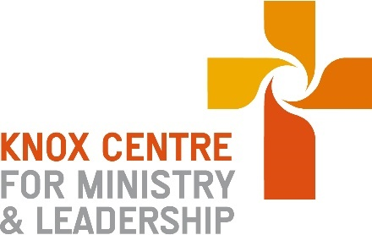
Presbyterian Church of Aotearoa New Zealand

Application for Ministers Study Grant
Auditing “University of Otago/KCML Summer School
Course on Trauma-Informed Ministry”

Monday 27th – Friday 31st January 2025

This application must be submitted no later that Friday 13th December 2024. Please send to registrar@knoxcentre.ac.nz
No late applications will be accepted.

Your name
Your email address
Your residential address

Your bank account details (name and account number)
Are you a minister in good standing in the PCANZ? | Y / N | Has your study leave proposal been approved by Presbytery? | Y / N
 | Please attach confirmation of good standing and Presbytery approval

